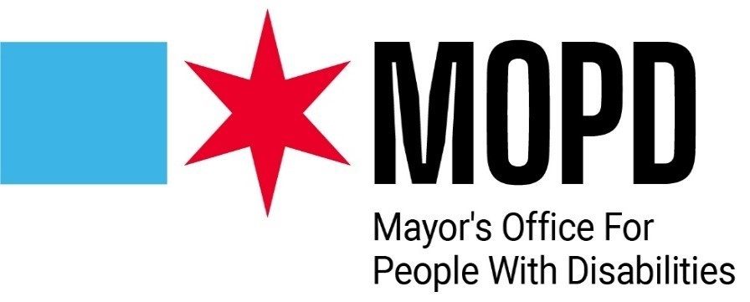

Know Before You Go: 2025 Thrive Together Wellness Fair

**Date:** Wednesday, March 12, 2025

**Time:** 1:00 pm - 4:00 pm

**Location:** Central West Community Center, 2102 W. Ogden Avenue, Chicago, IL

**No advance signups required.**

**No cost for the activities at this event.**

**No age limit for this event.**

**You do not need to arrive when it starts or stay for the whole event.**

# Getting to Central West Community Center

[**Check out this Social Story on How to Get to Central West Community Center**](https://sway.office.com/6QwKJmdaf7FvP5pA?ref=Link)

**By public transportation:** Our field office building is a 10-minute walk from the Illinois Medical District Blue Line stop (when you exit the station, walk south on Damen Avenue until you reach Ogden, then turn right and walk southwest on Ogden and you will see the building after a few blocks). You can also take the 157 bus which stops right in front of our building, or the 50 bus and get off at Damen and Polk, then turn left on Ogden.

**Paratransit drop-off:** PACE paratransit drop off/pick up is in front of the main entrance.

**Parking information:** Part of our field office parking lot will be available to the public (enter Ogden Avenue southwest entrance). Additional parking is available at Cook County Juvenile Center Parking Facility located at 1100 S. Hamilton Avenue, which costs $2.00 per day.

# What to Expect at the Event

* Inside the Central West Community Center, signs will direct you to the event hall. You can also ask at the front desk and they will show you the event hall.
* At the entrance to the event hall, a MOPD staff member will greet you. They may ask you about your accessibility needs. They may ask you if you would like to attend a breakout session (more information on those below).
  + They will not ask you if you signed up beforehand or for a fee.
  + You can ask them if you have any questions about where to go.
* There will be **24** **Community Resource Tables** with partner representatives and information at each table. You can go to every table or pick a few that you are interested in. You can talk to the partner representatives at the fair, pick up some brochures, flyers or informational booklets to read later, or both.
* The **Chicago City Clerk**’s office will be onsite to print new **CityKey IDs**. This is a photo ID for City of Chicago residents, available at no additional cost. If you would like a CityKey ID, they will give you an application to fill out and take your photo.
* There are **three breakout sessions** you can attend at no additional cost. These will be held either in the conference room to the side of the event hall, or in the main event hall.
  + From **1:30 to 2:15**, **Ada S. McKinley** will present an educational session about the different kinds of therapy and counseling. This breakout session will be in the conference room.
  + From **2:30 to 3:00**, **Trilogy** will present an information session on wellness in the workplace. This breakout session will be in the conference room.
  + From **3:00 to 3:30**, the **Chicago Park District** will teach a **seated aerobics class** in the front of the main event hall.
* There will be food trucks in the parking lot before and during the event. The food is not included but available to purchase. These are the kinds of foods you can expect:
  + Bert’s Jerk Grill & Seafood—[View menu](https://static1.squarespace.com/static/654e80bc6aee961a27ab7208/t/6571d9148e0c792543bae5fa/1701959964475/menu-2024-BERTSJERK.pdf)
  + Tacos Mario’s--[View menu](https://www.tacosmarios.com/menu)

# Accessibility at the Event

## Make your accessibility request before you go!

* Email Jocelyn Romasanta ([jocelyn.romasanta@cityofchicago.org](mailto:jocelyn.romasanta@cityofchicago.org))
* Or call (312) 746-5743

## Stop by the MOPD Resource Table at the event to request access!

* American Sign Language
* Wayfinding Assistance

# Event Participants

|  |
| --- |
| * Access Living |
| * Ada S McKinley Community Services |
| * Agents of Hope Training and Information Center |
| * AmeriCorps Vista |
| * Anixter Center |
| * Chicago House & Social Service Agency |
| * Chicago Police Department |
| * Chicago Public Library |
| * City Clerk |
| * CRSA * Illinois Treasurer’s Office |
| * JCFS Chicago |
| * Mental Health America of Illinois (MHAI) |
| * MOPD |
| * NAMI Metro Suburban |
| * Rush |
| * Shirley Ryan |
| * Sinai Community Institute |
| * The Chicago Lighthouse for the Blind |
| * Trilogy Inc. |
| * Thresholds * T-Mobile Accessibility |