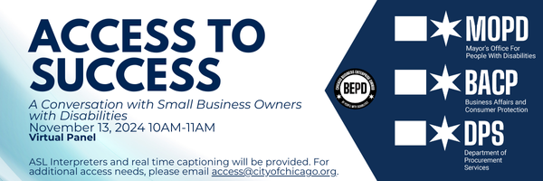

**Wednesday, November 13, 2024**

10:00 AM-11:00 AM

**[Register today!](https://forms.office.com/g/NKLQQH5jAi)**

* **Hear from Chicago business owners with disabilities** on a panel moderated by Mayor’s Office for People with Disabilities Commissioner Rachel Arfa
* Learn about the [City of Chicago’s Business Enterprises Owned by People with Disabilities (BEPD) Program](https://www.chicago.gov/city/en/depts/mopd/supp_info/business_enterprisesownedbypeoplewithdisabilitiesbepdinitiative.html).

Hosted by MOPD in collaboration with the [Department of Procurement Services (DPS)](https://www.chicago.gov/city/en/depts/dps.html) and the [Department of Business Affairs and Consumer Protection (BACP)](https://www.chicago.gov/city/en/depts/bacp.html).

ASL Interpreters and real time captioning will be provided. For additional access needs, please email [access@cityofchicago.org](mailto:access@cityofchicago.org).