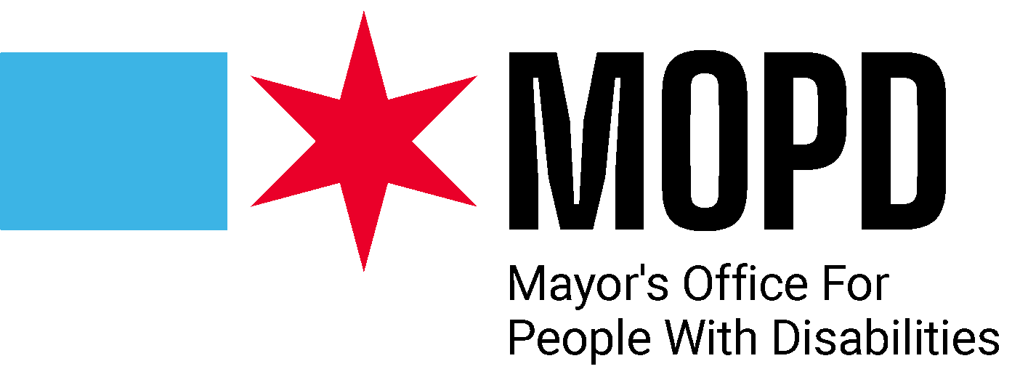

**You are invited to apply to become a member of The Mayor’s Office for People with Disabilities (MOPD) Advisory Committee!**

 With the vision of making Chicago the most accessible and inclusive city in the world, MOPD understands the importance of engagement with our disability community and strives to build an advisory council to provide feedback on issues facing our disability community.

If you are interested in participating in the MOPD Advisory Committee, please complete the required application. This is a one-year commitment. Meetings are anticipated to occur on a quarterly basis.

**Completed applications should be submitted to Kierra Johnson, MOPD Staff Assistant at Kierra.Johnson@cityofchicago.org by Monday, December 2, 2024. Please contact Kierra at 312-744-2909 if you need assistance in completing this application.**

**MOPD Advisory Committee Eligibility**

* Submit a completed application by December 2, 2024 along with a short bio or current resume
* Identify as an individual with a disability
* Be a Chicago resident
* Be at least 14 years of age

Advisory Committee members should share MOPD's goal of increasing accessibility and inclusion in Chicago, while bringing their unique perspectives to help shape the City's efforts to support our disability community. Formal educational or professional experience is not required for this role, but critical thinking, curiosity and a willingness to engage in intersectional discussions are important.

**Application Questions**

**Name**

**Email**

**Phone**

**Employer**

**Title**

**Are you an individual with a disability?**

**Why are you interested in participating in the Advisory Committee?**

**What disability subject matter areas are you most interested in?**

**Describe your involvement in the disability community, professionally or through your lived experience.**

**Are you an active member of, or have you been a member of, any disability advocacy organizations or groups?**

**What issues do you feel are most pressing to our disability community at this time?**

**All applications should be submitted with a short professional bio or current resume.**

**MOPD plans to get back to applicants before the end of 2024.**

**Thank you for your application!**