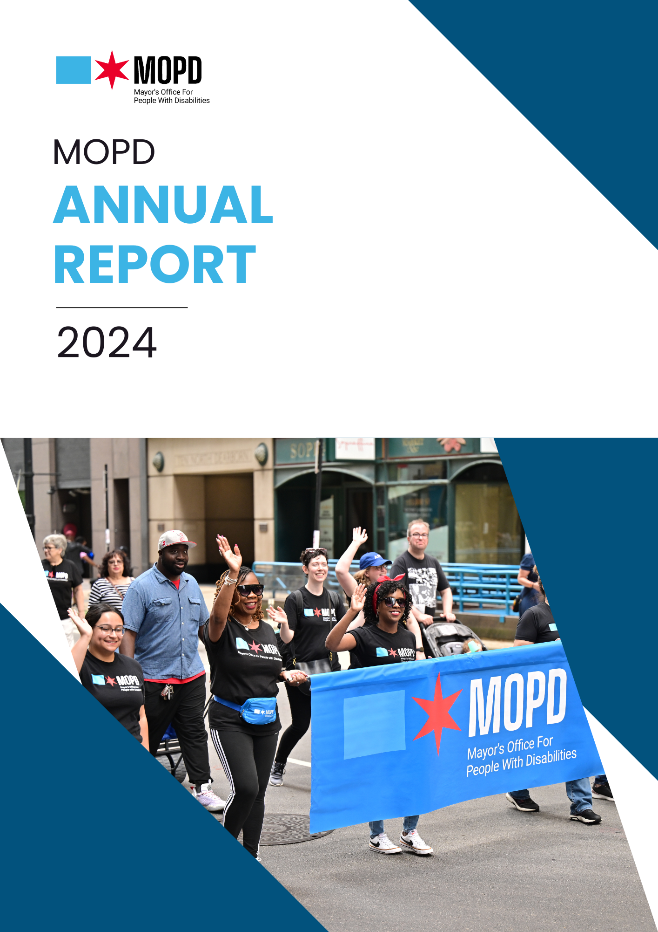
DRAFT DOCUMENT

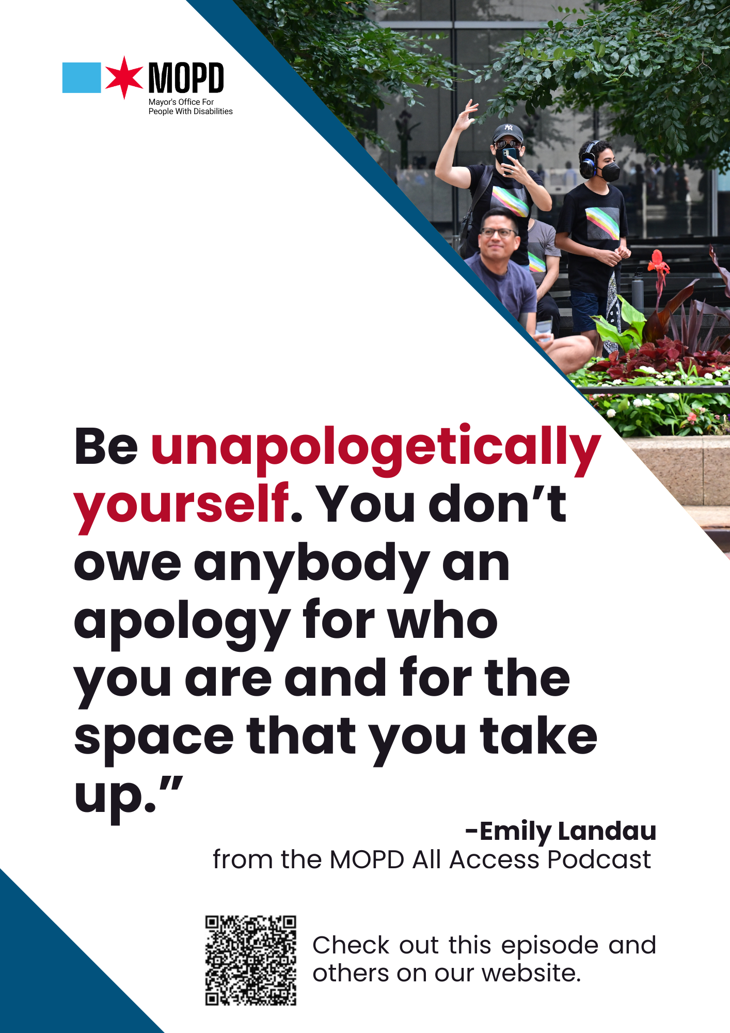
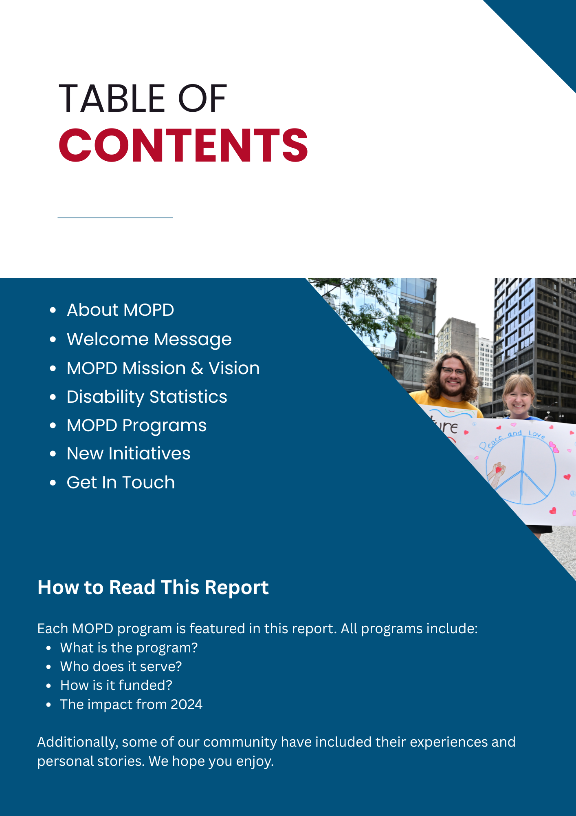
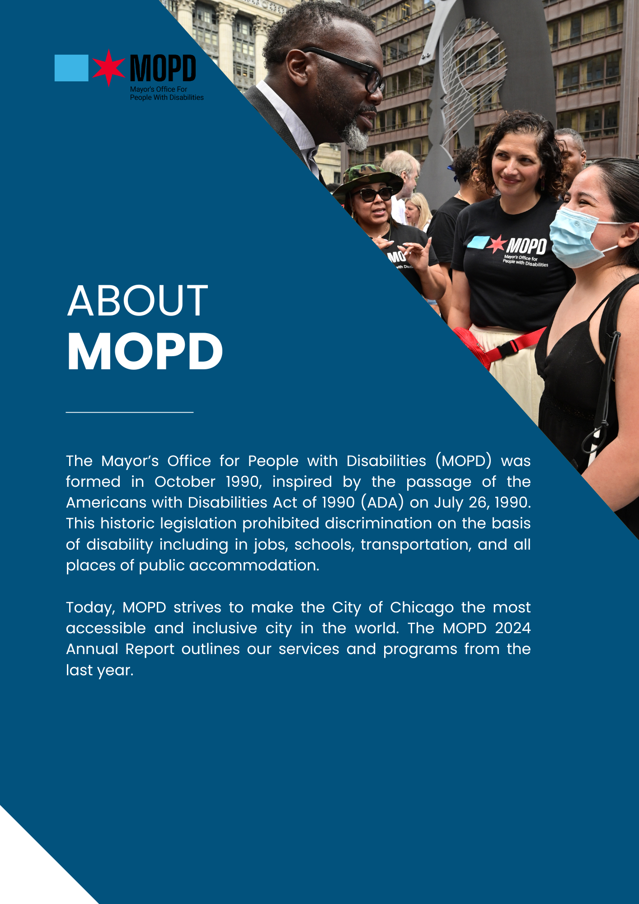
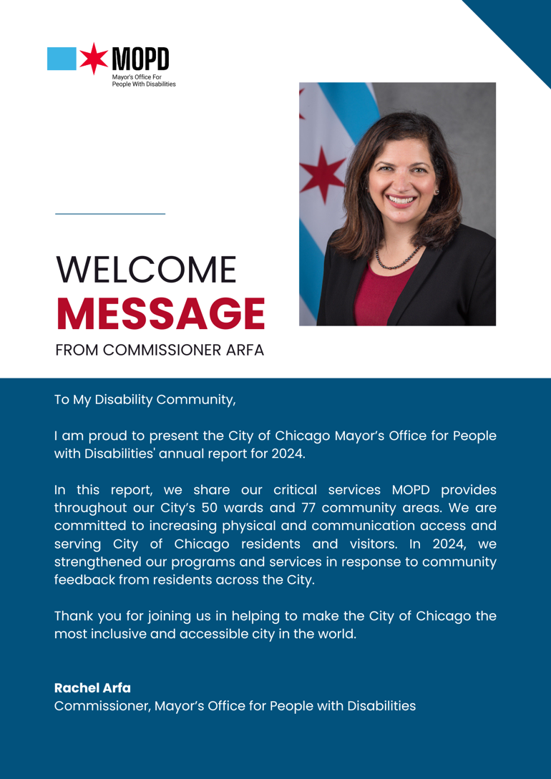
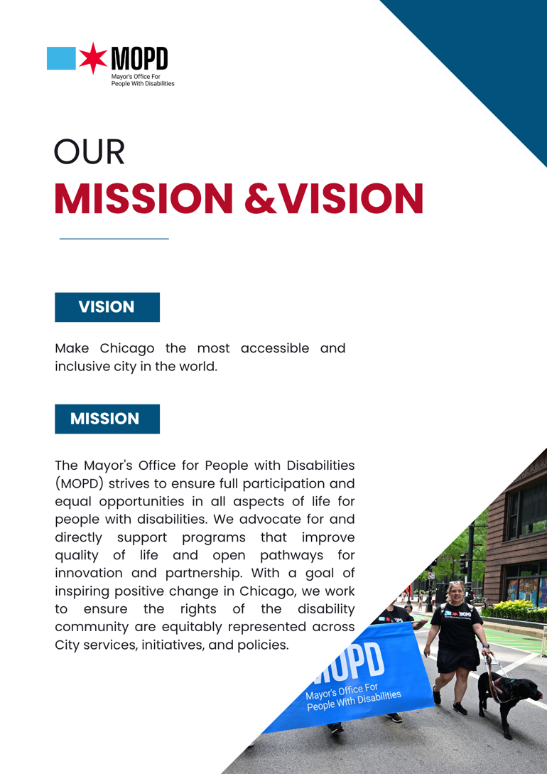

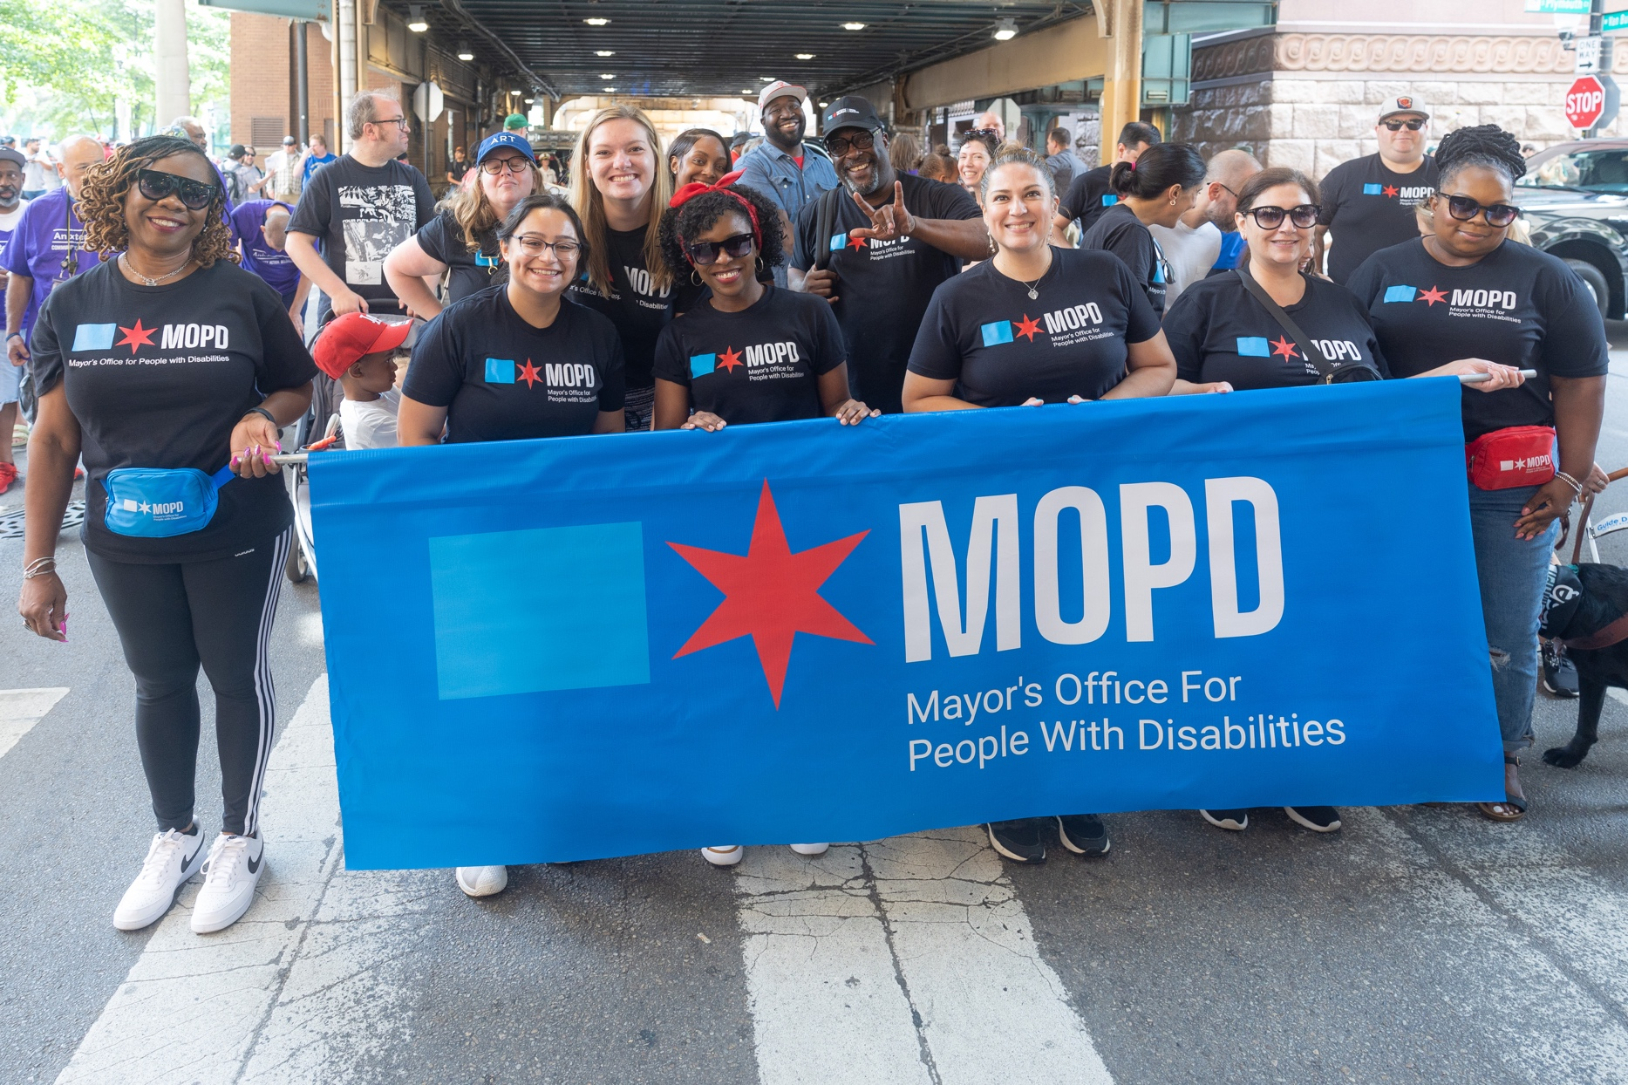
What is Disability?
Disability Statistics

Understanding Disability
Disability has many definitions. It is something that changes how an individual interacts with others and/or the world around them. Some are born with disabilities, while others acquire a disability later in life.

Disability In Chicago
More than 1 in 4 (26.8%) Chicagoans have a disability. This is consistent with national data, which shows that about 27 percent of Americans report having a disability.
In Chicago, two age groups have the highest rate of disability:
- Young adults between the ages of 18 and 29 years old (39.2%)
- Older adults ages 65 and older (40.8%)

Forty-one of Chicago’s 77 community areas have a higher rate of people with disabilities than the citywide rate. Community areas with the highest rate of disabilities include:
- Burnside (55.3%)
- Fuller Park (44.6%)
- West Garfield Park (44.2%)
- Englewood (42.2%)
- North Lawndale (41.6%)
The Austin neighborhood continues to report the most people with disabilities (25,609 residents, 33.6%), followed by Lakeview, Belmont Cragin, Uptown, and West Town.

Interested in More?
To learn more, check out the collaboration between the Chicago Department of Public Health (CDPH) and the Mayor’s Office for People with Disabilities (MOPD), “Accessible Healthy Communities,” on the MOPD website.
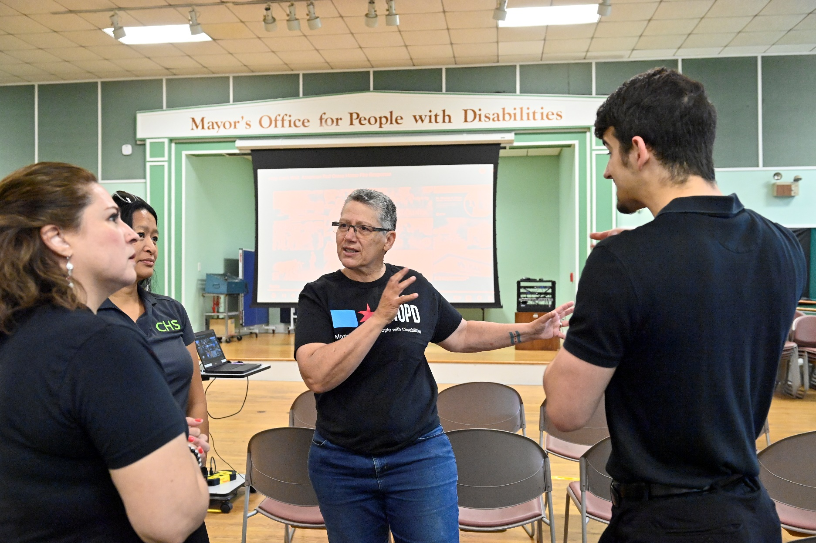
Disability Resource Unit

What is the Disability Resource Unit?
The Disability Resource Unit (DRU) provides two different services:
- Information & Referral
- Independent Living Program
Information and Referral
Our Information & Referral team answers questions and connects Chicagoans to disability resources.
Independent Living Program
Our Independent Living Program (ILP) provides personal assistance, home delivered meals, and assistive devices to support the independence of people with disabilities living in the community.
- Our Personal Assistance (PA) program provides up to 6 hours of in-home support for activities of daily living, such as housekeeping, grocery shopping, and personal care.
- Our Home Delivered Meals program provides nutritious meals for individuals with disabilities who do not have a support system and cannot access meals.
- Our ILP team can provide assistive devices. Examples include a shower chair to support daily hygiene or utensil grips for eating.
NEW! In 2024, MOPD and its delegate agency successfully implemented the "preferred worker" option for personal assistance services. Individuals with disabilities can now designate someone to be their personal assistant. Preferred workers go through a hiring and training program with our partnered delegate agency.

Who does Information & Referral Services serve?
- Chicago residents with disabilities

Who does IPL serve?
- Chicago residents with disabilities under 60 who meet income-specific qualifications

How is the Disability Resource Unit funded?
This program is funded through a Community Development Block Grant (CDBG).

2024 Impact
Information and Referral connected Chicago residents with services through 4,425 service encounters including emails, phone calls, and walk-ins. In-home services and transportation are the top two requested services.
Four-hundred and forty (440) unique individuals were served through the ILP program throughout the 50 wards of Chicago in 2024. Personal Assistance provided 11,586 service hours to 135 Chicagoans. Our Home Delivered Meals program served 62,910 meals.

From Our Community…
A participant in the Independent Living Program experienced discomfort and difficulty when sitting. He received a Heavy-Duty Chair with full back padding and padded arm rests, which allowed him to enjoy family gatherings in maximum comfort and great relaxation, including his birthday celebration.
Illinois Telecommunication Access Corporation

What is Illinois Telecommunication Access Corporation?
Our Disability Resource Unit gives captioned and amplified phones to qualified individuals who are deaf, hard of hearing, or have a speech disability through Illinois Telecommunication Access Corporation (ITAC).

Who does Information & Referral Services serve?
- Illinois residents
- Has a landline and/or cellular phone service (Pre-paid cellular phones allowed)
- Has signed approval by a medical professional that verifies the applicant’s hearing loss or disability
Participants are eligible for a new phone every 3 years.

Interested in ITAC services?
Visit a Disability Resource Specialist at one of our locations to try out phones.
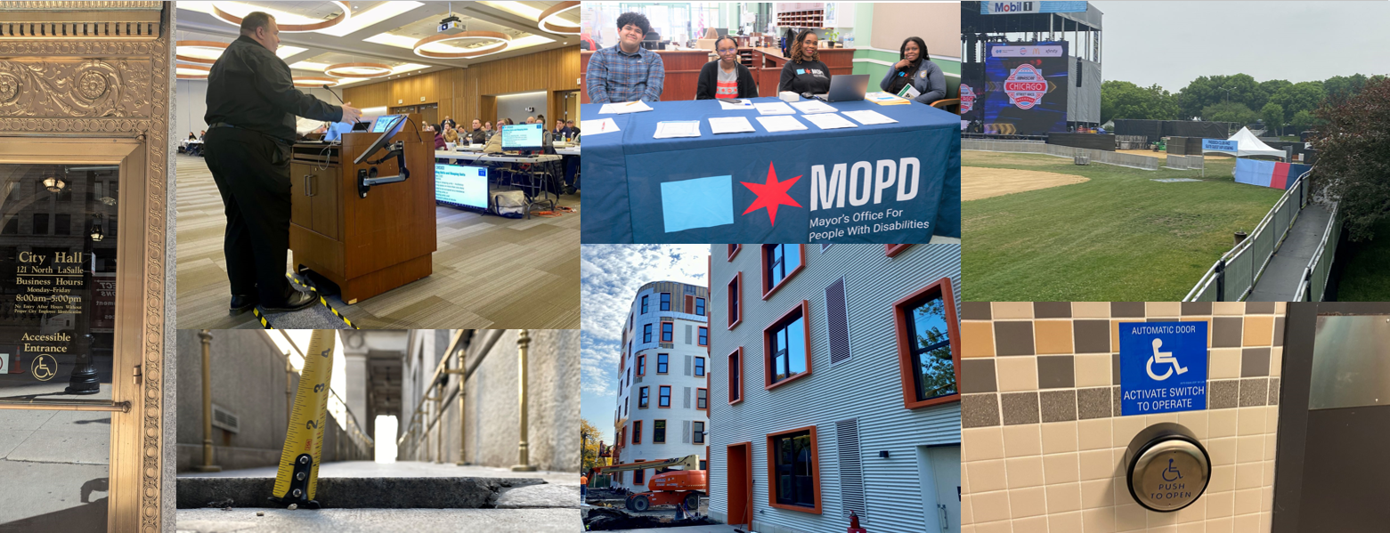
Accessibility Compliance Unit

What is the Accessibility Compliance Unit?
The Accessibility Compliance Unit (ACU) oversees the physical accessibility of City of Chicago buildings and housing through:
- Accessible Housing
- Permit Review and Compliance
- Title II Review
Accessible Housing
Our team’s housing coordinator connects individuals with accessible housing supports. Individuals can also use our online Housing Locator, which allows individuals to filter for accessibility features. Our team ensures accessibility of multifamily housing through design and permit review for affordable housing developments funded with government assistance, contributes to the City code compliance process, and ensures compliance with City and State accessibility standards.
Permit Review and Compliance
Our team also does site and building inspections, pre-permit and permit reviews, and provides technical assistance to architects, contractors, and real estate developers to ensure buildings and facilities in Chicago are accessible. Our permit review process includes:
- Review of architectural design proposals for buildings and facilities in the City of Chicago through advising design professionals, developers and builders on accessibility codes, regulations, best practices and technical standards. These reviews occur at two very important phases of a project's planning:
  - a) Preliminary design and design development: ACU and design professionals discuss design proposals and drawings during pre-permit meetings to find design deficiencies.
  - b) Review of completed designs that are permit-ready by ACU when the permit application is routed by the Department of Buildings to MOPD's plan reviewer.
- Code check to ensure compliance of the architect's documents with the Chicago Building Code's accessibility provisions and technical requirements of the ICC Standard.
Title II Review
Our inspectors complete in-person public-facing City facility assessments and prepare compliance reports listing access barriers. These assessments are part of the City's in-progress ADA Title II Self-Evaluation and Transition Plan and will be used for the next phase of the program, implementation, led by MOPD, Fleet and Facility Management (2FM), and the Public Building Commission (PBC). These Departments collaborate closely on assessments and the first phase of implementation through professional services offered by PBC's architectural consultants.

Who does ACU serve?
- Those who design, build, or alter structures within Chicago, such as architects, contractors, and developers
- Chicago residents seeking accessible housing options

How is ACU funded?
This program is funded through City of Chicago corporate funding.

2024 Impact
The ACU completed 54 ADA Title II facility assessments in 2024, which are assessments of facilities to make sure they meet minimum ADA requirements. The Unit also completed 530 pre-permit and 308 permit reviews to ensure accessibility of building projects in Chicago. The Unit responded to 1,029 calls for accessible housing and completed 52 accessible housing inspections.

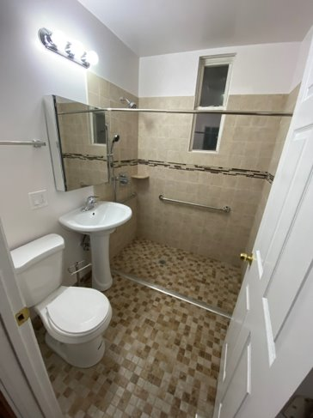
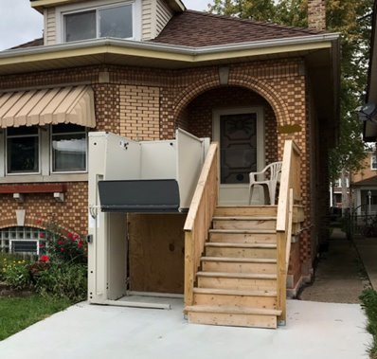
What is the HomeMod Program?
HomeMod Program
The MOPD Home Modification Program (HomeMod) provides accessible home renovations to help people with disabilities live more independently. Eligible Chicagoans who have or acquire disabilities can receive modifications such as vertical platform lifts, roll-in showers, ramps, lowered cabinets, and widened doorways. MOPD manages the entire process, including hiring qualified contractors and ensuring all work meets legal and safety standards.

Who does HomeMod serve?
- Chicago residents with disabilities who meet income-specific qualifications
- Proof of disability is required
- Available to both owners and renters, given landlord permission

How is HomeMod funded?
This program is funded through a Community Development Block Grant (CDBG), City of Chicago corporate funding, and the Chicago Housing Authority (CHA).

2024 Impact
The HomeMod program delivered accessible modifications to 176 clients in 2024, along with 88 platform lift repairs and 33 lead remediations. A new HomeMod project was completed every 1.45 days in 2024, and the average time from application to completion was 124 days.
Using over $3.9 million in funding, the program completed accessibility modifications that remove physical barriers and allow residents to navigate their homes with greater ease and dignity. Whether enabling someone to safely bathe, exit their home without assistance, or access their kitchen and bathroom independently, each project directly improved quality of life and supported life and aging in place for people with disabilities across Chicago.

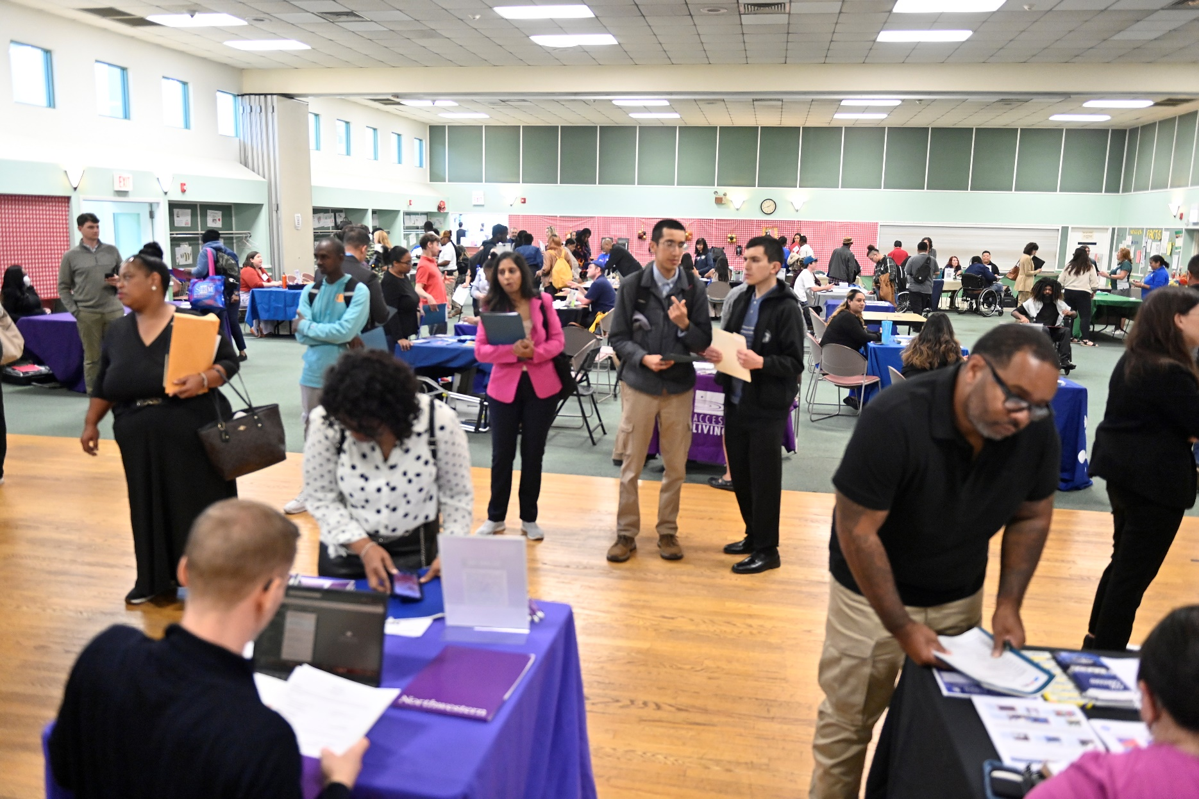
Career Center

What is the MOPD Career Center?
The MOPD Career Center helps job seekers with disabilities apply for jobs, prepare for interviews, and participate in the job placement process The Career Center works with job seekers regardless of career path, level of education, or previous work experience. Our four Career Placement Counselors (CPC) work one-on-one with job seekers. Our Benefits Counselor provides information and answers questions about working while getting Social Security Income (SSI) or Social Security Disability Income (SSDI) benefits. Through our holistic model, our team creates employer partnerships and trains on inclusive hiring practices and employment. Our employer partners include:

- BMO
- Chicago Humanities Festival
- Chicago Public Schools
- Farmer’s Fridge
- Griffin Museum of Science and Industry
- Northwestern Memorial Hospital
- Rush University Medical Center
- Whole Foods

Who does the Career Center serve?
- Chicago residents with disabilities between the ages of 16 and 59
- No proof of disability is required; We ask that you identify as having a disability

How is the Career Center funded?
This program is funded through City of Chicago corporate funding.

2024 Impact
In 2024, the MOPD Career Center served 232 people, representing 47 of Chicago’s 50 wards, and made 62 job placements. The average time from enrollment to a new job was 116 days.

From Our Community…
Amy graduated with a Bachelor of Science and worked with a CPC to help her find positions, update her resume, and strengthen her interview skills. She now works as an Inpatient Scheduler at Shirley Ryan Ability Lab and still meets with her CPC to discuss her long-term career goals.
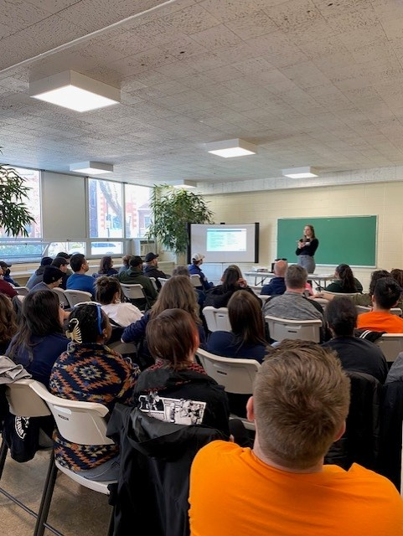
Training Services

What are Training Services?
MOPD Training Services trains and educates City departments, sister agencies, and outside organizations who are interested in learning more about disability-related topics. The program provides custom in-person or virtual training sessions on disability and access, inclusive employment, and other disability topics.

Who do Training Services serve?
- Chicago-based organizations and businesses, City departments, Sister Agencies
- The trainings are provided at no cost to participants

How are Training Services funded?
This program is funded through City of Chicago corporate funding.

2024 Impact
In 2024, MOPD held 47 training sessions for over 1,700 individuals on topics related to disability, inclusion, and accessibility. This includes a series of trainings for Ward representatives where we reached 38 wards.

From Our Community…
“Thank you ladies so much for the presentation yesterday. I’m hearing from lots of people that the information was wonderful and informative. There is non-stop chatter today about the presentation and all positive.” – Beatriz Gomez, District Manager for Department of Family and Support Services
“The trainers were incredible! They were patient and empathetic, even with some challenging questions.” – Anonymous, Training Feedback Form
“This was a fantastic training. I appreciated how well-knowledged the presenters were on the topic and the pace of the presentation was perfect. I learned some new things that I'll be able to apply to my position. Thank you!” – Anonymous, Training Feedback Form

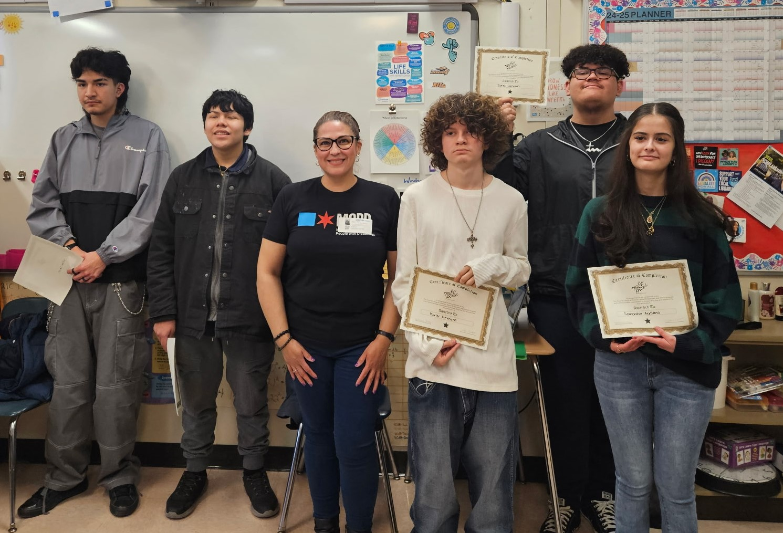
What is SUPPD?
Substance Use Prevention Program for the Deaf and Hard of Hearing
The Substance Use Prevention Program for the Deaf and hard of hearing (SUPPD) presents substance use prevention training to students who are Deaf and hard of hearing. Our Deaf trainers use adapted evidence-based curriculum to match the communication style of our students, using American Sign Language, interactive games, and slide decks with pictures.

Who does SUPPD serve?
- Students who are deaf or hard of hearing in 6th through 12th grades within the state of Illinois

How is SUPPD funded?
This program is funded through the Illinois Department of Human Services (IDHS).

2024 Impact
SUPPD served 88 students who are deaf or hard of hearing in Spring and Fall 2024. They also attended outreach events where information was disseminated to over 864 individuals.

From Our Community…
A Deaf and hard of hearing teacher in Chicago shared her experience with us: “We had the MOPD's Substance Use Prevention Program for the Deaf and Hard of Hearing (SUPPD) this year and it has been a positive experience. The coordinator and presenters have been so flexible and supportive knowing that they are presenting to high school students and scheduling is difficult. The students were initially hesitant to participate in such a program, thinking it would not apply to them, but the curriculum has been engaging. Students participate and apply the knowledge they have gained in other parts of their day. I would recommend this program to other schools that are looking for [social emotional learning] support for students.” - Carrie Skoczylas, Teacher of the Deaf/Hard of Hearing at Curie Metropolitan High School
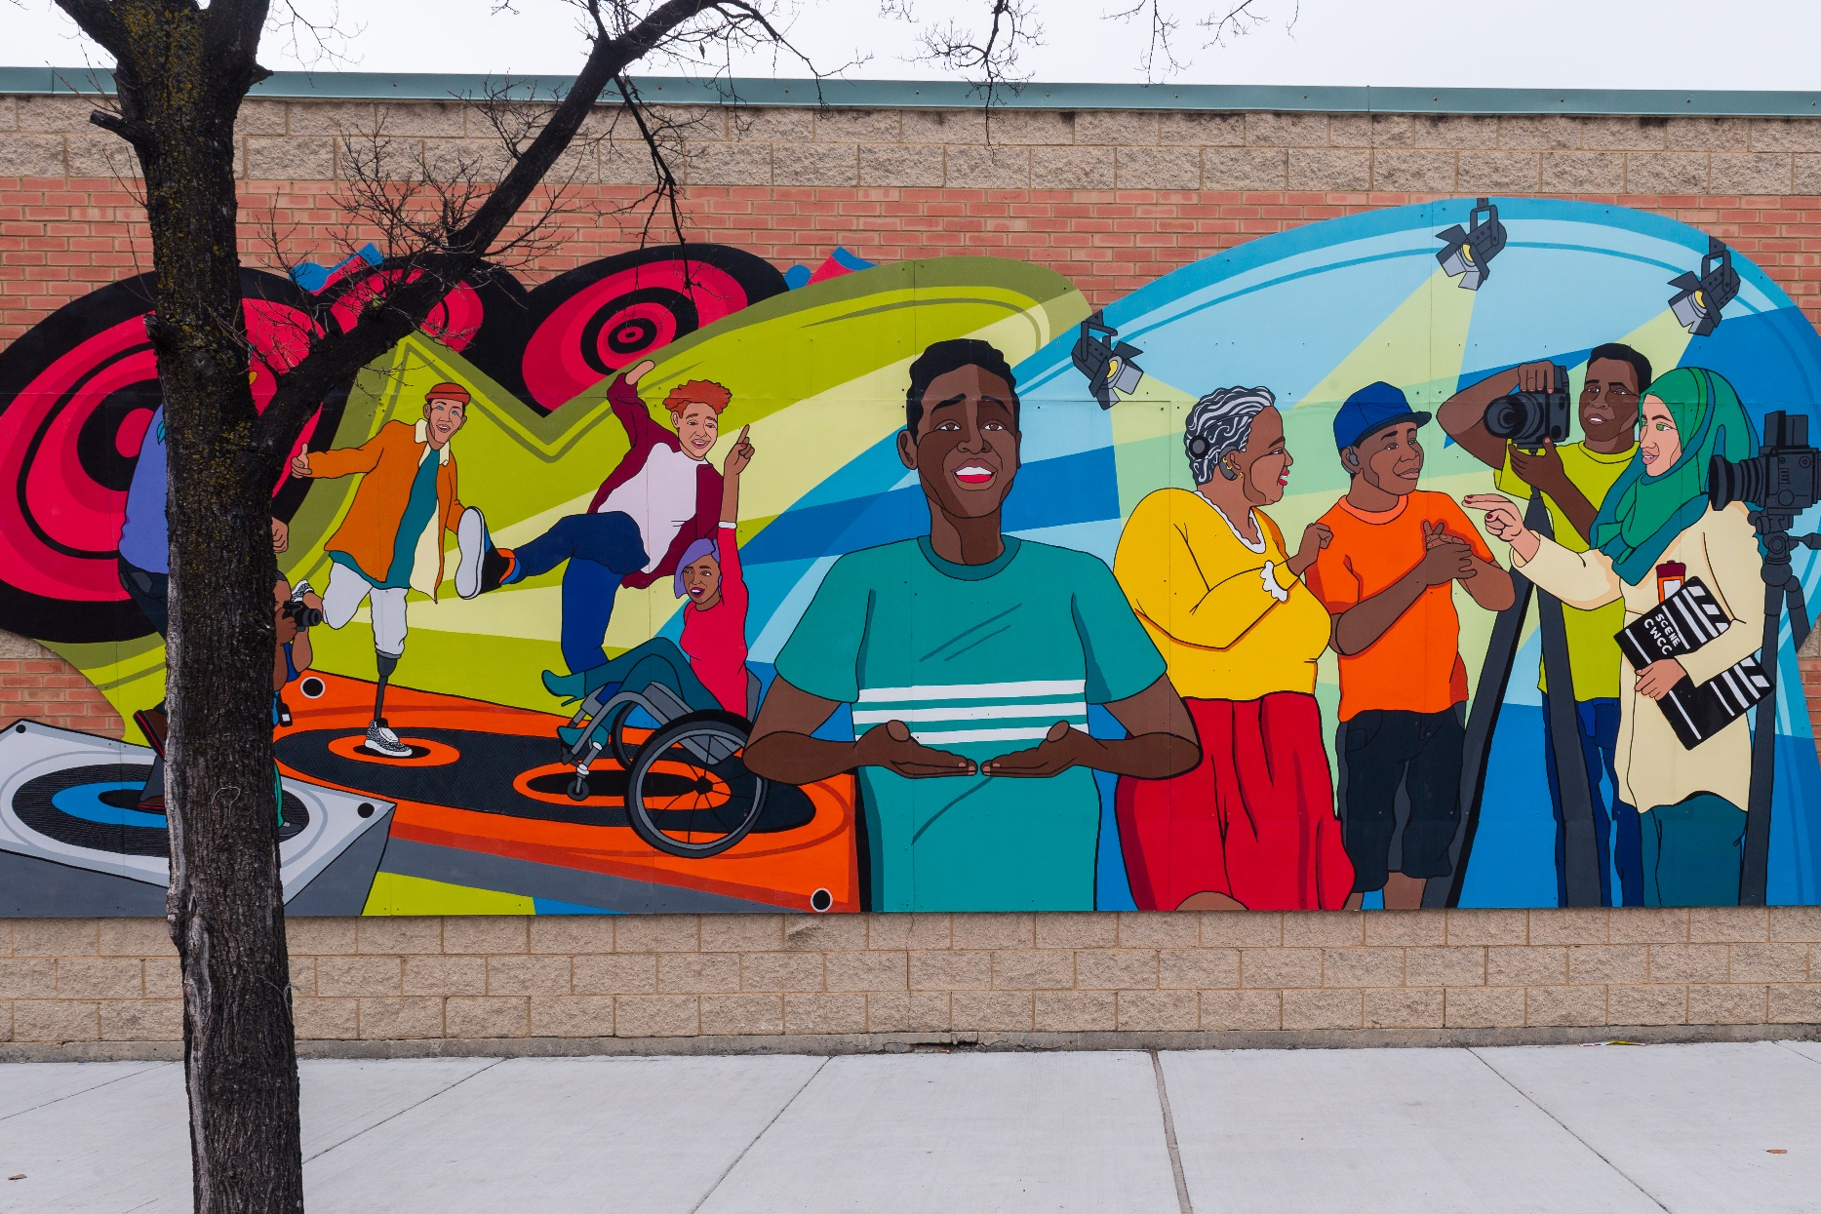
Disabled Survivors of Gun and Community Violence Project

What is the Disabled Survivors of Gun and Community Violence Project?
The Disabled Survivors of Gun and Community Violence (DSGCV) Project supports community-based organizations and advocates that provide violence prevention and intervention services. We partner with these organizations to increase disability awareness and inclusive programming and services. Through collaboration we identify training opportunities, no cost accessibility improvements, and long-term accessibility goals.

Who does the DSGCV Project serve?
- Chicago community-based organizations who have gun prevention or intervention services
- Chicagoans with newly acquired disabilities due to gun or community violence
- Chicagoans who had disabilities prior to experiencing gun or community violence

How is the DSGCV Project funded?
This program is funded through earmark funding from Senator Tammy Duckworth and the U.S. Department of Justice

2024 Impact
In its first year, the DSGCV Project served 12 community-based organizations and provided 214 direct services to individuals or those who serve individuals impacted by gun violence.

From Our Community…
After continued partnership, trainings, and events, we received the following from our partners: “Thank you so much for the follow-up and huge thank you for providing additional resources. The partners thoroughly enjoyed the training, and I've shared your contact with so many of the partners on the call so they will be reaching out to you soon if they haven't already done so." - Brianna Hobbs -Teamwork Englewood Health and Wellness Program Coordinator
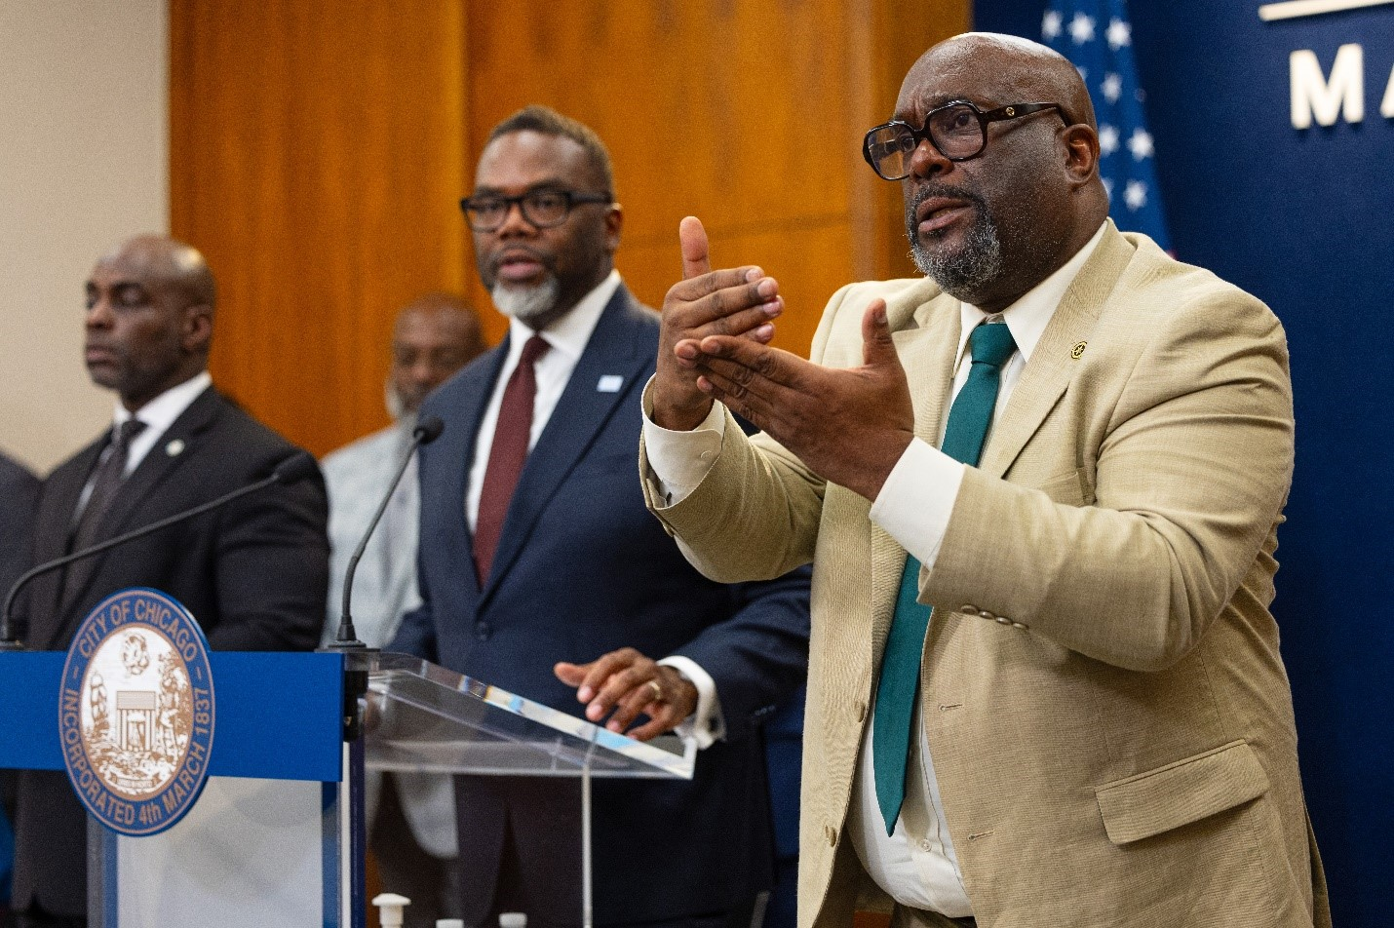
Communication Access Team

What is the Communication Access Team (CAT)?
The Communication Access Team (CAT) is a team of four, full-time staff American Sign Language (ASL) interpreters who are licensed and certified in Illinois. Our team provides communication access for both deaf/hard-of-hearing and hearing individuals for City of Chicago events.

Who does CAT serve?
- Individuals who are deaf/hard of hearing and request an ASL interpreter for City events, services, and programs

2024 Impact
Our team provided 1,989 hours of American Sign Language interpretation in 2024 to both City of Chicago employees and the public.

From Our Community…
One City resident reported that she went to countless town hall meetings struggling to find interpreters, getting low quality service, and missing a lot of information. She requested MOPD interpreters through her Alderperson. MOPD provided ASL interpreters, and she reported it was the first time she had been able to fully participate in a town hall and understand the information being shared. She hugged both interpreters, thanked us profusely, and asked how she could get MOPD Interpreters back for every meeting because it was such a positive experience.

New Initiatives in 2024

Diverse Learners Fund
We partnered with Ada S. McKinley Community Services to award over 5 million dollars in cash payments to 8,000 students with disabilities. These $500 cash payments supported our students with disabilities and their families with educational costs to help with the impacts of COVID.
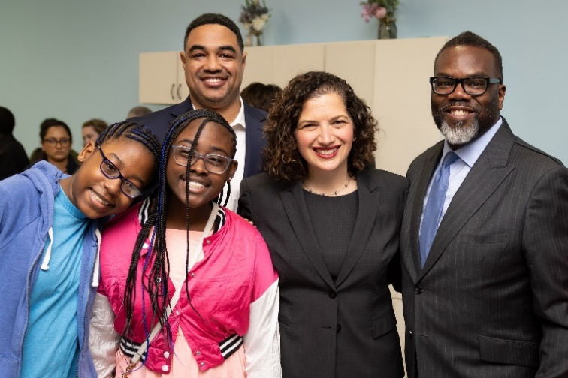

Housing Locator
This year, we launched a housing locator, which is an online resource to help Chicagoans find housing. Individuals seeking housing can filter for accessible housing options and their desired location. Check it out!

Access Calendar
To connect our disability community with accessible events, we launched our first ever Access Calendar. Through our website, event hosts can submit their events and list the accessibility considerations that will be provided at the event. Members of the disability community can use this calendar to find accessible events happening around Chicago! Find an accessible event!

Events and Initiatives in 2024
We were busy in 2024! Check out our events from this year and come see us at one of our future events!

Access Officers
The Access Officer Program is an MOPD initiative to partner with other City of Chicago Departments and Sister Agencies to increase accessibility and inclusion. Access Officers kicked off in 2024 with a round table discussion with Mayor Brandon Johnson.
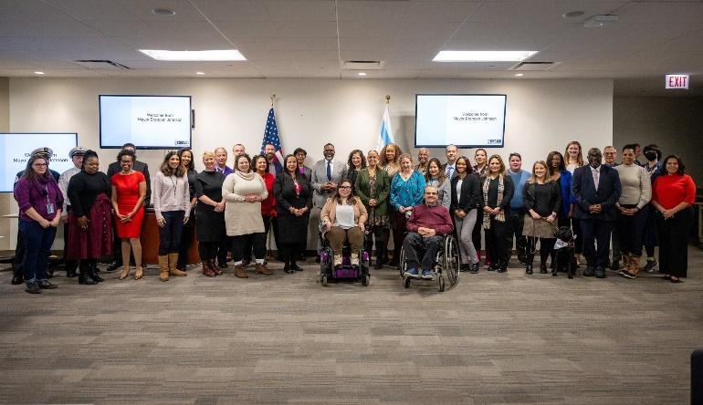

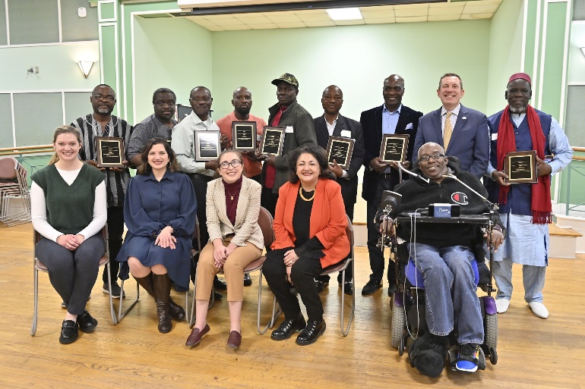

Wheelchair Accessible Vehicle (WAV) Taxi Driver Award
Each year, we partner with the Department of Business Affairs and Consumer Protection (BACP) to award taxi drivers who demonstrate exemplary service towards people with disabilities. This year, we honored Godfrey U. Abangwu, Olugbemiga Adejumoh, Kingsley Agyarko, Babacar Fall, Babatunde Ogundare, Julius Osunde, Yeboah B. Sefah, and Nelson Ado Zungu. Thank you for your service to our City!

Civic Engagement
MOPD Commissioner Rachel Arfa engaged with youth to help them understand their right to vote and why it matters. Young adults then went out to cast their votes after the event.
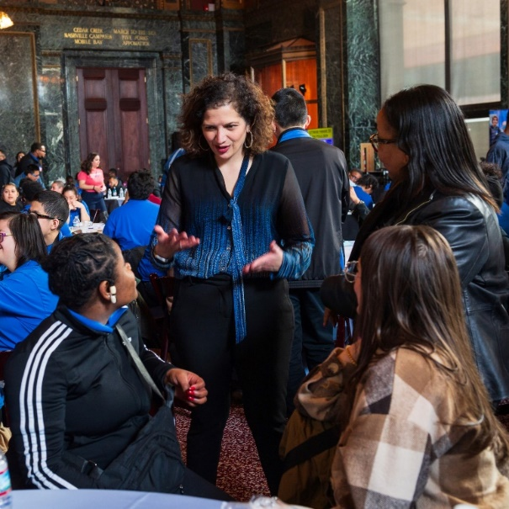

Inclusive Summer Jobs Expo
We partnered with the Mayor’s Office and the Department of Family and Support Services (DFSS) to host youth and young adults with disabilities and connect them to summer jobs. Youth had the opportunity to apply to DFSS’s One Summer Chicago (OSC) internship opportunity with support from staff.
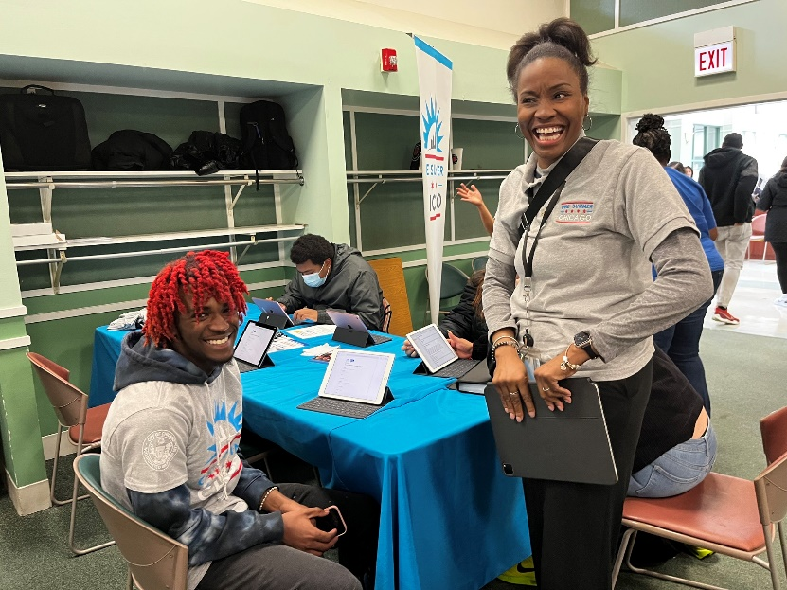

Global Accessibility Awareness Day
We were thankful to host a panel of digital accessibility experts including our City’s Chief Information Officer and employees from Infiniteach and the Chicago Lighthouse to discuss accessibility in digital design.
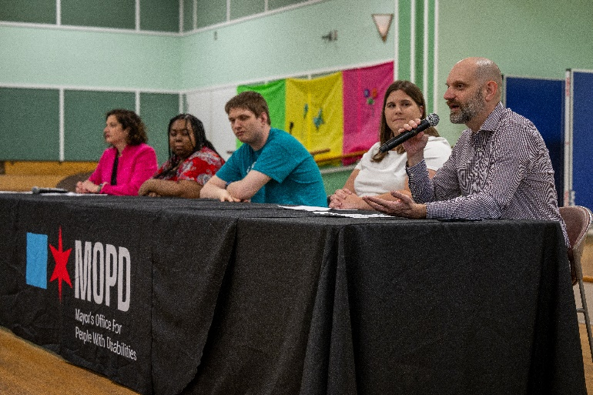

Visual Fire Alarm Safety Event
In collaboration with American Red Cross and the Chicago Hearing Society, MOPD hosted a visual fire alarm safety event to educate individuals about adaptive fire safety and sign up for visual alarm instillation.
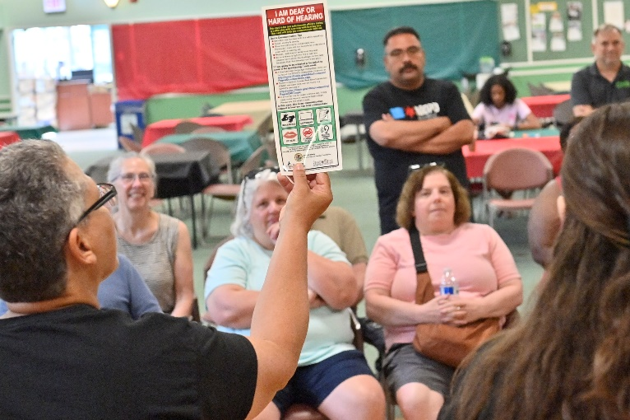

Mansoor Khan Public Service Award
The Mansoor Khan Public Service Award is awarded annually to an employee who exhibits kindness, humility, a willingness to help others, and dedication to public service. Congratulations to our 2024 recipient, Frida Morales. Frida is an accountant and devoted City employee who has been with MOPD for nearly 25 years. She is an invaluable resource ready to help our team, pays close attention to detail, and explains city and financial processes in a kind way.
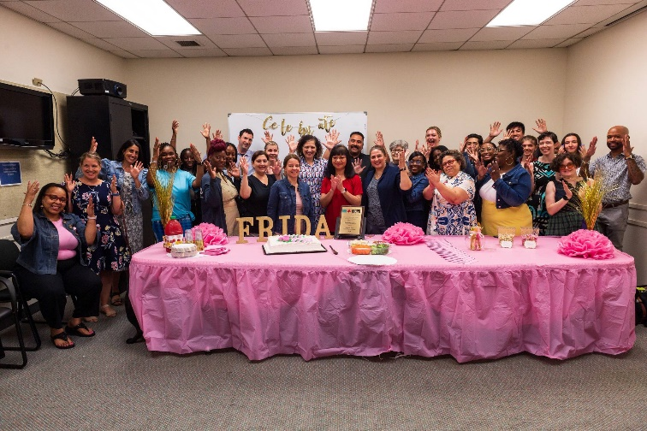

Uber/Lyft Service Animal Event
We are grateful to Uber, Lyft, and BACP for prioritizing accessibility for service animal handlers! This event allowed drivers and transportation services to meet with service animals and their handlers to learn about why accessible transportation is important.
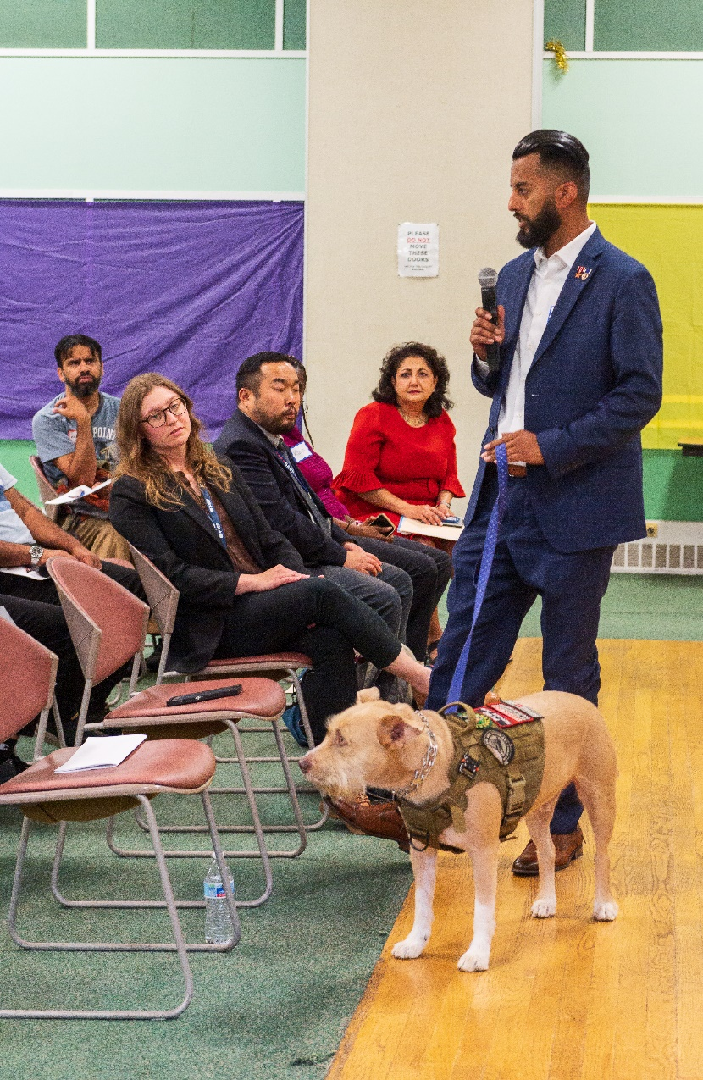

Person of the Year Award
Devices 4 the Disabled, a Chicago organization that redistributes donated medical equipment to those in need, awarded Commissioner Rachel Arfa with the Person of the Year Award. Mayor Brandon Johnson and Devices 4 the Disabled’s Bob Shea surprised Commissioner with the Award.
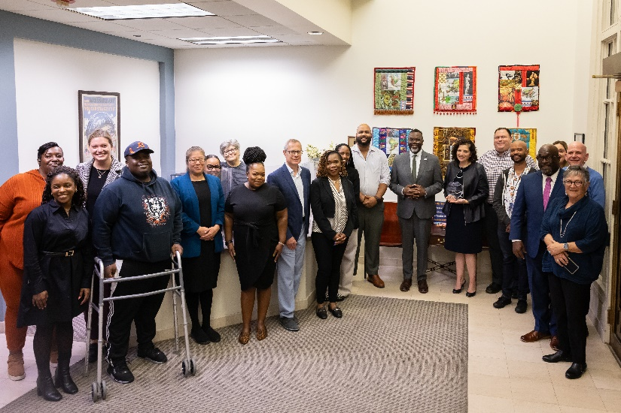

Ending Subminimum Wage
As of July 1st, Chicago ended the 14(c) subminimum wage for workers with disabilities. This was a U.S. Department of Labor program that allowed companies to pay disabilities less for the same work. Mayor Brandon Johnson and Commissioner Rachel Arfa held a roundtable discussion with disability advocates and business leaders to celebrate this important step for disability employment.
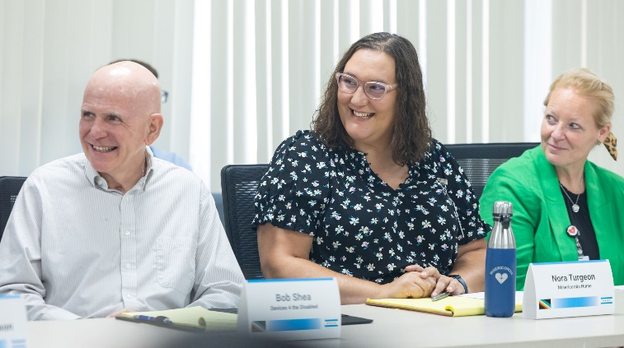

July: Disability Pride Month
Every July, we celebrate Disability Pride Month with the Disability Pride Parade and the Anniversary of the Americans with Disabilities Act (ADA). This year was the 34th Anniversary, which we celebrated with an event at City Hall.
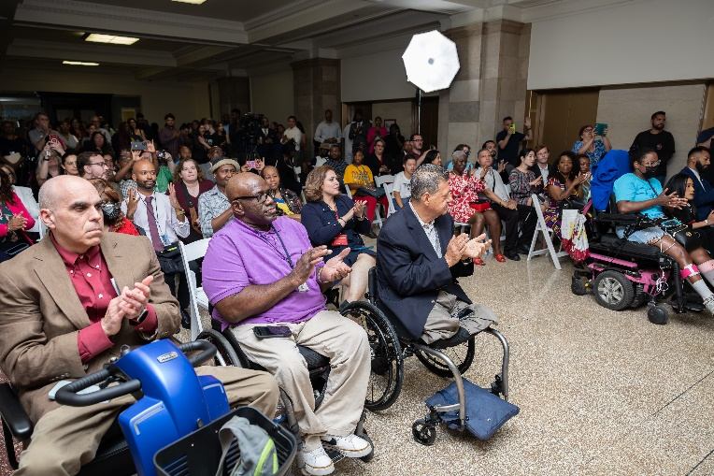

Accessibility at the Democratic National Convention
MOPD partnered with the Democratic National Convention Committee, a non-political organization, to help support accessibility during the Democratic National Convention (DNC). We collaborated with Choose Chicago, the Illinois Hotel and Lodging Association, and the Illinois Restaurant Association to provide training on how to serve customers with disabilities as they visit Chicago.

MOPD Interns
Our summer interns were across our Disability Resource Unit, HomeMod Program, Accessibility Compliance Unit, Substance Use Prevention Program for the Deaf and Hard of Hearing, and Career Center. They explored City resources and contributed to accessibility in the City of Chicago. Thank you to Danielle, Sophie, Kaitlyn, Harrison, Andy, and Toni!
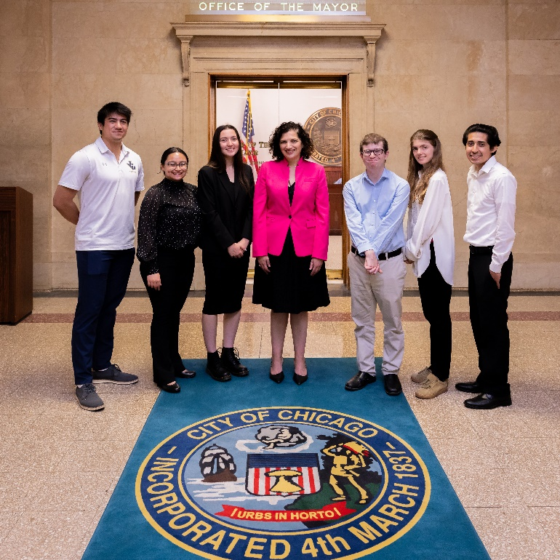

Career Center Employer Networking Event
Our job seekers and employer partners made connections at our event to mark National Disability Employment Awareness Month. Individuals were able to share their resumes and receive professional headshots.
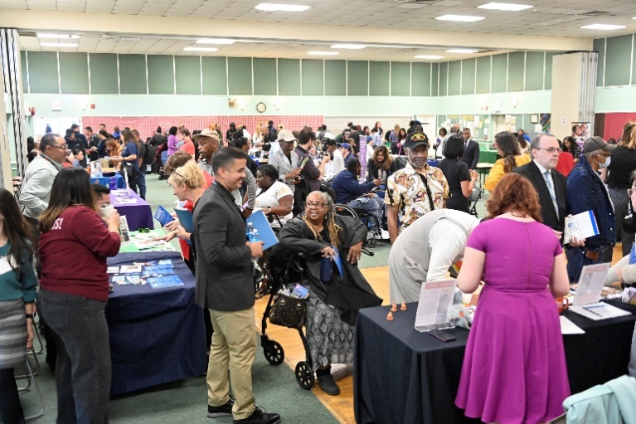

MOPD Podcast
Check out co-hosts Lauren Hooberman and Christina McGleam on our fully accessible podcast, All Access, on Youtube, our website, or wherever you get your podcasts.
Episode 7: Career Center Connections
Episode 8: Chicago Public Schools Leaders Speak Out
Episode 9: Occupational Therapy—A Health Profession and So Much More
Episode 10: Mental Health Beyond Awareness
Episode 11: In Our Summer Jobs Era
Episode 12: Celebrating the 34th Anniversary of the Americans with Disabilities Act
Episode 13: Making the 2024 DNC Accessible
Episode 14: Meet the Communication Access Team
Episode 15: Recognizing the Humanity of Disability with Emily Ladau
Episode 16: What It’s Like to Win a Gold Medal with Paralympian Kendall Gretsch
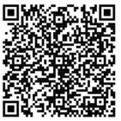
Scan the QR code to check out our podcast!

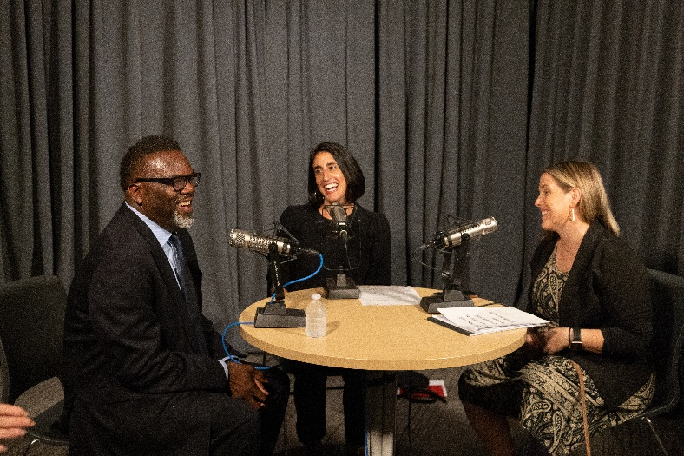

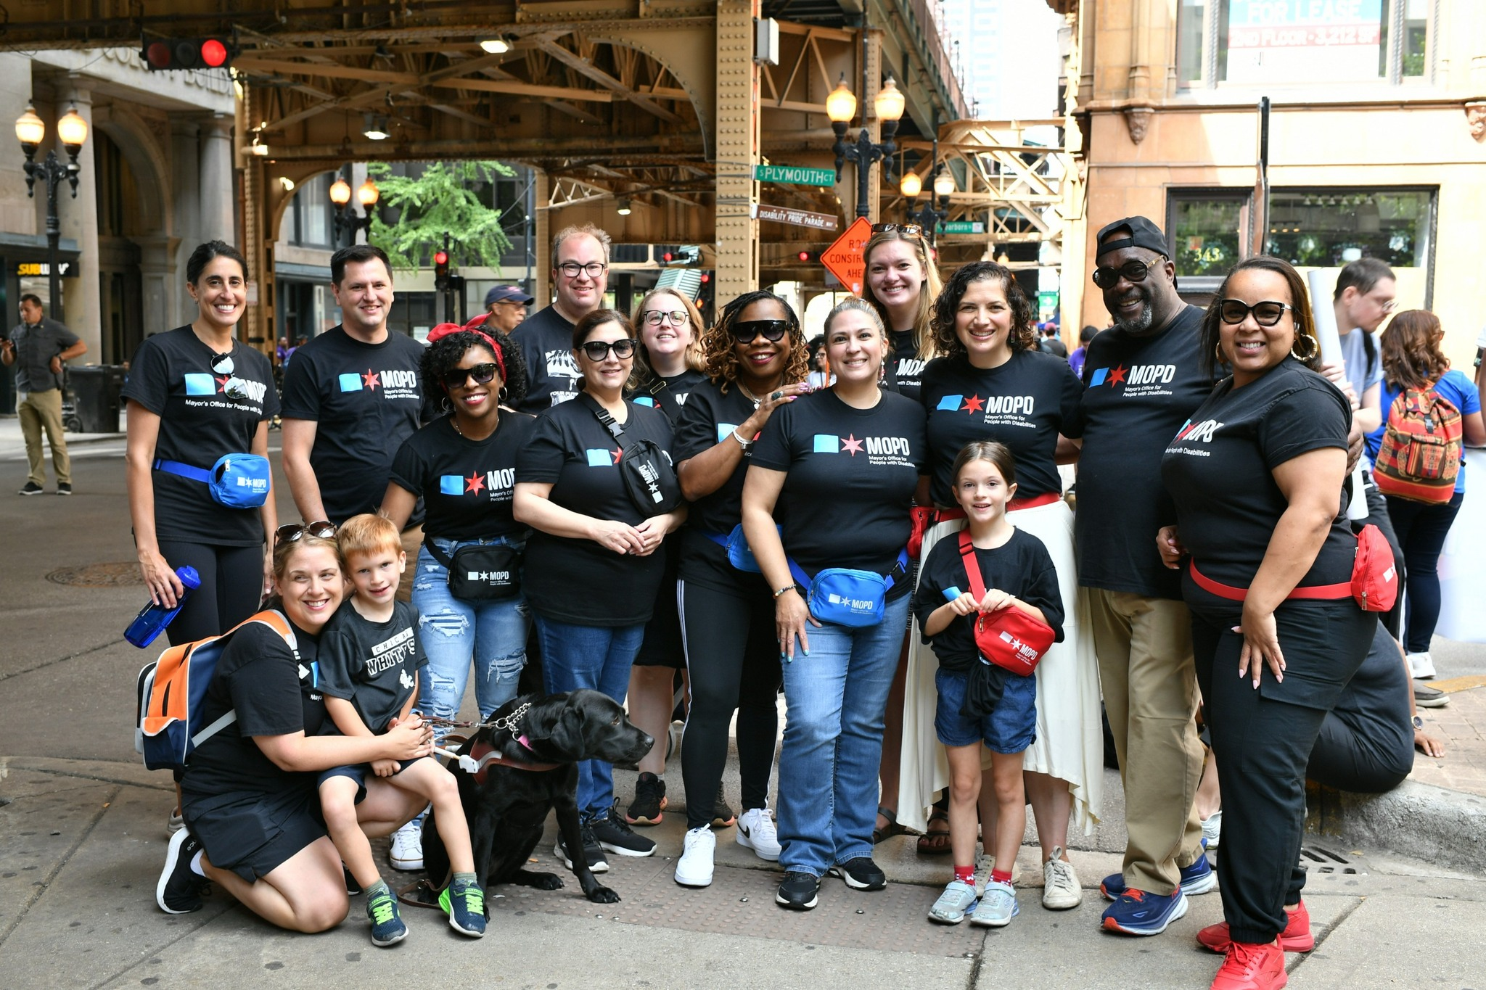
Visit Us!
Get in Touch
Stop by one of our two Chicago locations to connect with a Disability Resource Specialist:
City Hall, Room 104  121 N. LaSalle St.  Chicago, IL 60602 | Central West Community Center  2102 W. Ogden Ave.  Chicago, IL 60612

Connect With Us!
MOPD is active on social media, and we would love to interact with you! We post about all MOPD events and other accessible events on our social media channels. Find us on X or Instagram at @MOPDChicago or on Facebook or LinkedIn at “Mayor’s Office for People with Disabilities.”

Sign Up For Our Newsletter!

Get monthly updates about events and disability-related content through our MOPD Newsletter!
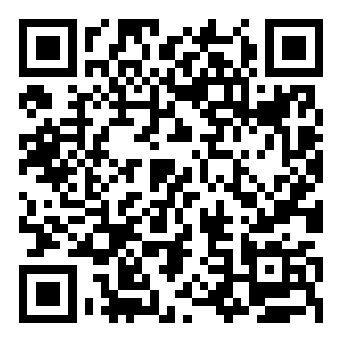

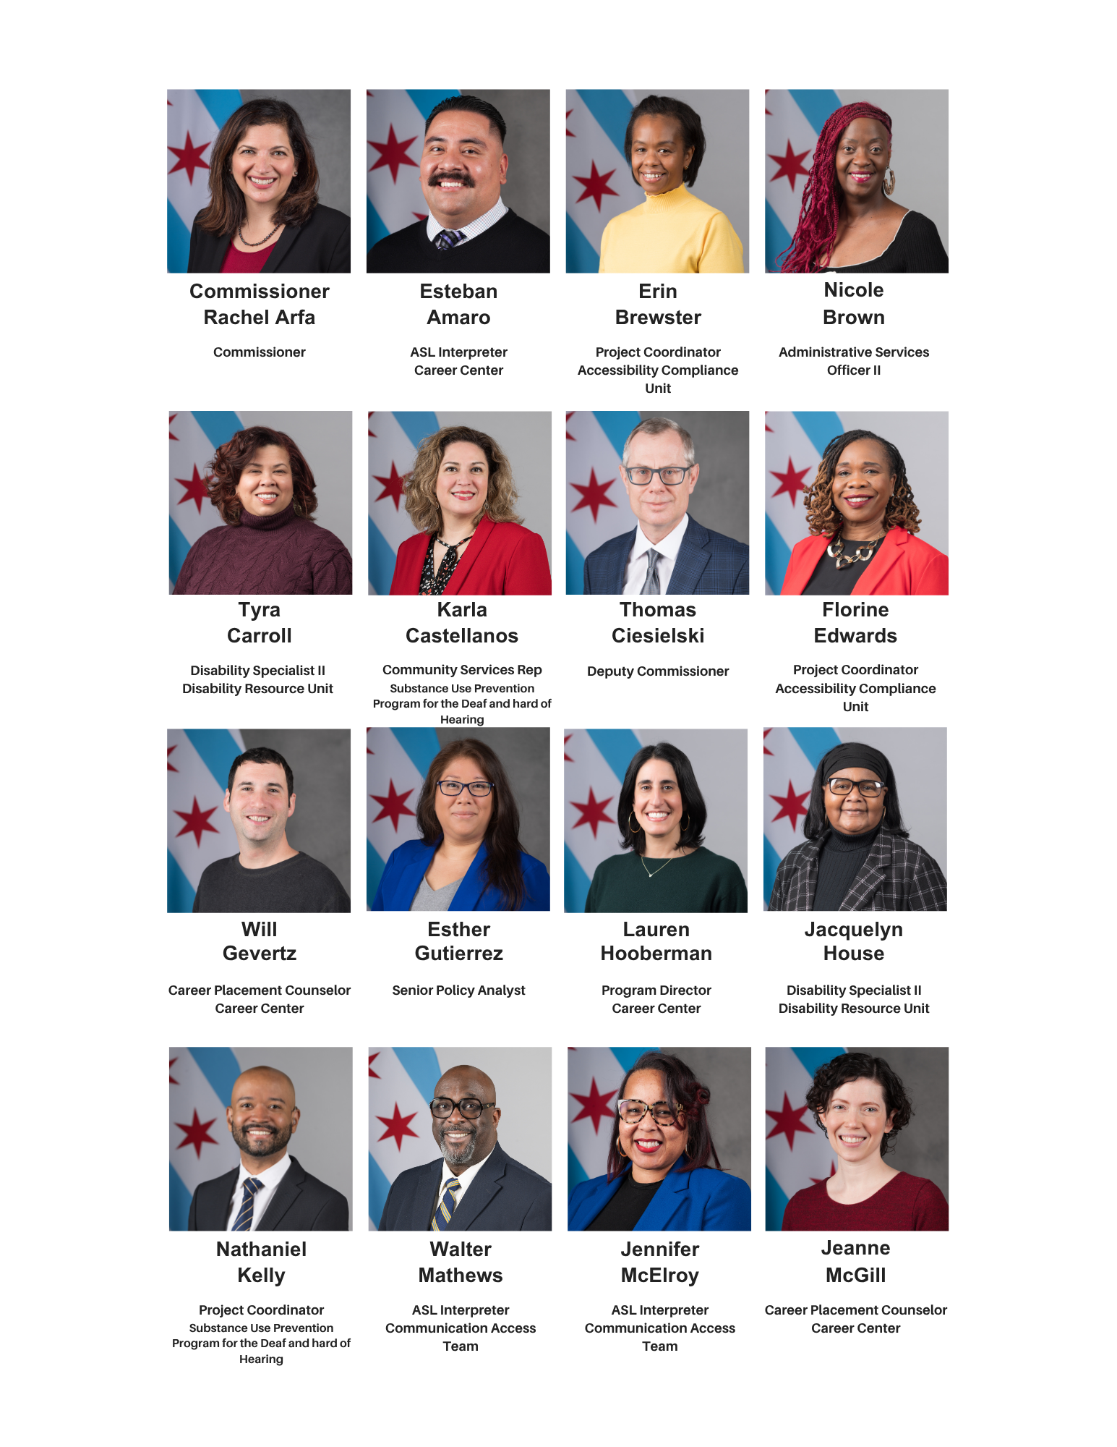
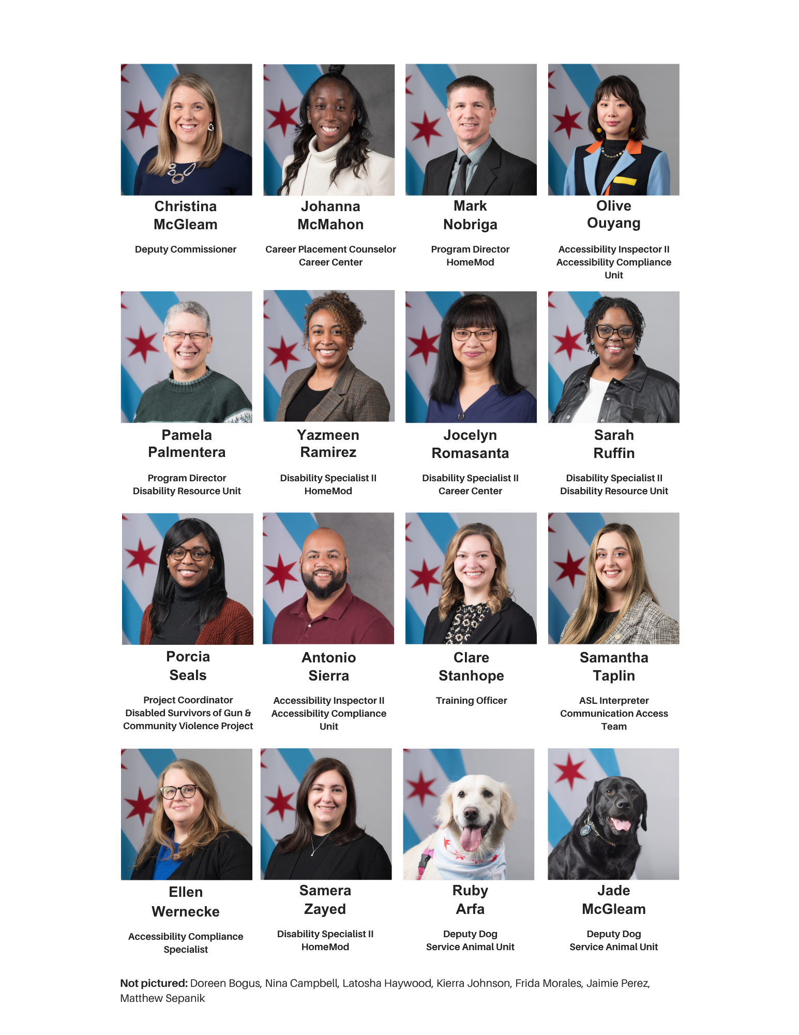

Chicago Department of Public Health. (2023). Healthy Chicago Survey 2023 Dataset. https://www.chicago.gov/city/en/depts/cdph/supp_info/healthy-communities/healthy-chicago-survey.html
Center for Disease Control and Prevention (2023). Disability and Health Data System (DHDS) https://www.cdc.gov/ncbddd/disabilityandhealth/infographic-disability-impacts-all.html

