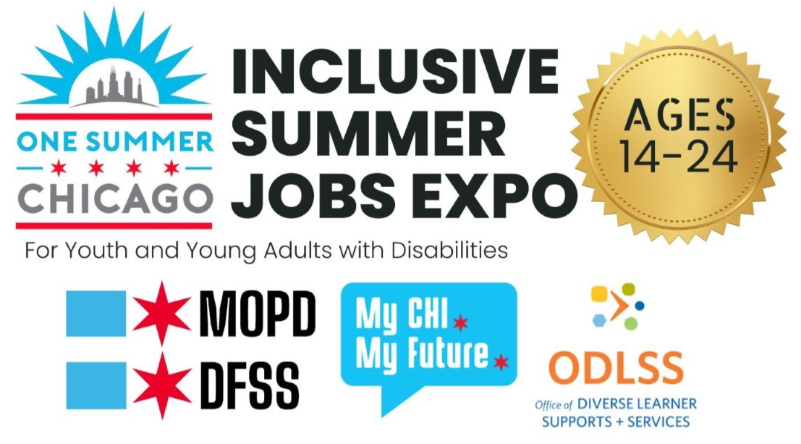

Know Before You Go: 2024 Inclusive Summer Jobs Expo

Date: Saturday, April 20, 2024
Time: 10:00 am - 2:00 pm
Location: Central West Community Center, 2102 West Ogden Avenue, Chicago, IL

Advance signups are recommended.
No cost for the activities at this event.
Food is not included in this event, but food will be available for purchase.
This event is intended for young adults ages 14-24, whose parents, guardians and/or caregivers are additionally welcome.
You do not need to arrive when it starts or stay for the whole event.

Contents of this document
Contents of this document 1
What to know about One Summer Chicago 1
Getting to Central West Community Center (2102 W. Ogden Ave.) 2
What to Expect at the Event 2
Scheduled events during the Expo 3
Make your accessibility requests before you go! 3
Stop by the MOPD Resource Table at the event to request access. Some common requests are for: 3
Event Participants 3
How to get a CityKey 4

What to know about One Summer Chicago
One Summer Chicago is an initiative that offers summer employment to youth between the ages of 14 and 24 through city partner agencies and organizations.
To apply for One Summer Chicago, you need to fill out an application on onesummerchicago.org by May 2, 2024.
- Most opportunities are for youth ages 16-24.
- Most programs will begin June 24 and end August 2, 2024.
- These are paid opportunities.
  - Some opportunities pay $15.80 an hour at least.
  - Some offer a stipend of $450 for 6 weeks.
- For your interview, you will need your Social Security number and either a government issued ID or birth certificate.
  - To prove Chicago residency, Chicago Public Schools ID, CityKey ID, and school records, such as ASPEN, are acceptable instead of a government-issued ID
- Once you have applied, you will hear from partners or agencies in May or June, either for an interview or with a job offer.
- If you are under the age of 18 and you are offered a position, your parent or guardian will have to sign a consent form for you to participate in the employment program.
- If you have another job, you can still participate in One Summer Chicago, as long as you can do both.

Getting to Central West Community Center (2102 W. Ogden Ave.)
Check out this Social Story on How to Get to Central West Community Center
By train: Our field office building is a 10-minute walk from the Illinois Medical District Blue Line stop. When you exit the station, walk south on Damen Avenue until you reach Ogden, then turn right and walk southwest on Ogden and you will see the building after a few blocks.
By bus: You can take the 157 bus which runs from Streeterville through the Loop and southwest to the IL Medical District and stops right in front of our building. You can also take the 50 bus, which runs south from Edgewater along Damen Avenue to the Orange Line stop at 35th and Archer. Get off at the Damen and Polk stop, then turn left on Ogden.
Paratransit drop-off: PACE paratransit drop off/pick up is in front of the main entrance.
Parking information: Part of our field office parking lot will be available to the public (enter Ogden Avenue southwest entrance). Additional parking is available at Cook County Juvenile Center Parking Facility located at 1100 S. Hamilton Avenue, which costs $2.00 per day.

What to Expect at the Expo
- Inside the Central West Community Center, signs will direct you to the event hall. You can also ask at the front desk and they will show you the event hall.
- At the entrance to the event hall, a staff volunteer will greet you. They may ask you about your accessibility needs.
  - You can ask them if you have any questions about where to go.
- There will be several Information Sessions offered with this event, at the following times:
  - 10:30 – Benefits Counseling
    - Learn about transition to work, financial independence, and federal/state benefits, such as Social Security Disability Income (SSDI).
  - 11:30 – Career Center First Job Prep
    - Understand the services offered by MOPD’s Career Center and some employment tips to prepare you for a first job!
- There will be over 20 Community Resource Tables with partner representatives and information at each table. You can go to every table or pick a few that you are interested in. You can talk to the partner representatives at the fair, pick up some brochures, flyers or informational booklets to read later, or both.
- There are two food trucks outside of the Central West Community Center in the parking lot (Tacomotora and Miss Tittle’s Cupcakes). Food is not included in this event.
- The Office of the City Clerk will be onsite offering the CityKey, a City of Chicago-issued ID available to Chicago residents.
  - With the CityKey, you can prove your identity officially, open a bank account, complete an I-9 in order to work, and receive other City services.
  - Please review the charts at the end of this document regarding what you need to bring to get a CityKey.

Scheduled events during the Expo
These events are optional. You do not need to sign up in advance to join these.
- From 10-10:30AM there will be a Benefits Counseling Presentation on how your summer job may affect any benefits (SSDI, SSI, or similar) you are currently receiving or may receive.
- From 11-11:30AM the Career Center will be holding a First Job Prep workshop.
- From 1-2PM a Career Placement Counselor will be available if you would like to discuss your resume, reasonable accommodations and how to disclose your disability to a potential employer.
- From 1-2PM the MOPD All Access Podcast will be recording—and they want to hear YOUR voice on summer jobs! Stop by to tell your story.

Make your accessibility requests before you go!
Please reach out to access@cityofchicago.org with any accessibility requests.

Stop by the MOPD Resource Table at the event to request access. Some common requests are for:
- American Sign Language
- Wayfinding Assistance

Event Participants

- Ada S. Mckinley
- Aspira
- Chicago Animal Care and Control
- Chicago Housing Authority
- Chicago Lighthouse
- Chicago Park District – Special Recreation
- Chicago Public Library
  - Teen Services/YOUmedia
  - Assistive Resources & Talking Book Center
- Chicago Public Schools – Office of Diverse Learners and Special Services
- Chicago Urban Art Retreat Center
- City Colleges of Chicago
- CityKey – Office of the City Clerk
- Department of Rehabilitation Services
- Free Spirit Media
- IL ABLE
- Lincoln Park Zoo
- Mayor’s Office for People with Disabilities
  - Career Center
  - Substance Use Prevention Program for the Deaf and Hard of Hearing (SUPPD)
- Meridian
- My CHI. My Future.
- Regional Transportation Authority (RTA)
- Social Security Administration
- YouthCare

Diverse Leaners Recovery fund program
The Mayor’s Office for People with Disabilities (MOPD) is working in partnership with Ada S. McKinley Community Services on a new grant program called Diverse Learners Recovery Fund. It is aimed at providing financial assistance to families of children with disabilities, a population that was disproportionately impacted by the COVID-19 pandemic. The Diverse Learners Recovery Fund will provide one-time grants of $500 to up to 8,000 eligible K-12 students through a lottery.
The eligibility requirements are:
- Reside in the City of Chicago
- Household Income less than 300% of the Federal Poverty Level (FPL)
- Student currently enrolled in K-12 Public or Private School
- Student has a disability covered by the Americans with Disabilities Act (ADA)
- Up to 2 eligible students per household
- Eligible parents or guardians can learn more and apply online at www.AdaMOPD.com. For questions, email MOPD@adasmckinley.org.

How to get a CityKey

In order to get a CityKey you need to prove your identity and your residency. Here are a few ways to do this. This is the list of all eligible documents.
- If you have a photo ID, you can apply with the following:
Either one of these: | Or two of these:
Driver’s License  U.S. or international passport  US Permanent Residency Card (“green card”), Certificate of Citizenship or Certificate of Naturalization  State of Illinois ID Card  US Work Permit or Current Employment Authorization Document  Native American Tribal Photo Identification Card | Illinois Temporary Driver’s License or Learner’s Permit  US Birth Certificate  School ID (valid within the past 3 years), or CPS School Enrollment Form  Social Security Card  RTA Reduced Fare or Free Fare permit  DFSS Participant Card or Enrollment Form  A letter verifying that you participated in One Summer Chicago last year  Parole or Supervised Release Agreement  Official Medicare or Medicaid Identification Card or Document  Cook County Department of Corrections ID Card  Illinois Department of Corrections Temporary Identification Card, Released Offender Identification Card, or Prisoner Review Board Order

- If you are between 14 and 21, and you don’t have a photo ID, but you have a parent, guardian, or foster parent with you, they can help you if you both bring the following:
You bring | Parent/ guardian/ legal custodian/ foster parent/ caseworker brings
Two of these:  US Birth Certificate  School ID (valid within the past 3 years), or CPS School Enrollment Form  Foreign ID or driver’s license  Social Security Card  Temporary learner’s permit or driver’s license  Student Ventra Card or Ventra U-Pass  RTA Reduced Fare or Free Fare permit  DFSS Participant Card or Enrollment Form  A letter verifying that you participated in One Summer Chicago last year  Parole or Supervised Release Agreement  Official Medicare or Medicaid Identification Card or Document  Cook County Department of Corrections ID Card  Illinois Department of Corrections Temporary Identification Card, Released Offender Identification Card, or Prisoner Review Board Order  Birth Certificate for your child  And one of these  Letter from a school, college or university with your Chicago address on it, within the 2023-2024 school year  CPS School Enrollment form for the 2023-2024 school year  Disability check issued by the State of Illinois  Verification of release from the US Department of Health and Human Services Office of Refugee Resettlement  US Citizenship and Immigration Services Order of Supervision (April 2023 or newer) | One of these:  Birth certificate  Adoption certificate  Letter from DCFS  Court order establishing legal guardianship or custodianship  Social Security Administration letter establishing the caretaker relationship  And EITHER One of these:  Driver’s License  U.S. or international passport  US Permanent Residency Card (“green card”), Certificate of Citizenship or Certificate of Naturalization  State of Illinois ID Card  US Work Permit or Current Employment Authorization Document  Native American Tribal Photo Identification Card  Or two of these:  U.S. Visa  Veterans Identification Card  US Birth Certificate  School ID (valid within the past 3 years), or CPS School Enrollment Form  Social Security Card  RTA Reduced Fare or Free Fare permit  DFSS Participant Card or Enrollment Form  A letter verifying that you participated in One Summer Chicago last year  Parole or Supervised Release Agreement  Official Medicare or Medicaid Identification Card or Document  Cook County Department of Corrections ID Card  Illinois Department of Corrections Temporary Identification Card, Released Offender Identification Card, or Prisoner Review Board Order

