# City of Chicago – Mayor’s Office for People with Disabilities (MOPD)

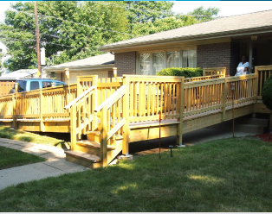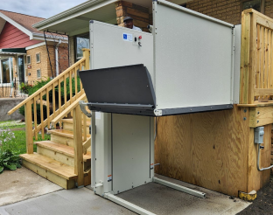**The HomeMod Program,  
For Disabled Survivors of Gun and Community Violence (DSGCV)**

## Now Accepting Applications

The Disabled Survivors of Gun and Community Violence (DSGCV) Project, part of the HomeMod Program, is currently accepting applications for individuals who have acquired a disability due to gun violence or community violence.  
  
Please note: Funding is limited and applications are reviewed on a rolling basis.

## What Home Modifications Are Available?

Modifications are determined based on need and available funding. A licensed contractor, in collaboration with MOPD staff, will conduct a comprehensive in-home assessment to identify improvements that promote safety, accessibility, and independence.  
  
Eligible modifications may include:

* Vertical platform lifts
* Ramps
* Chair lifts
* Bathroom accessibility improvements
* Other home modifications to support independent living

## Get in Touch

For more information or to apply, contact:  
Porcia Seals  
Project Coordinator, MOPD

porcia.seals@cityofchicago.org  
📞 312-744-0207