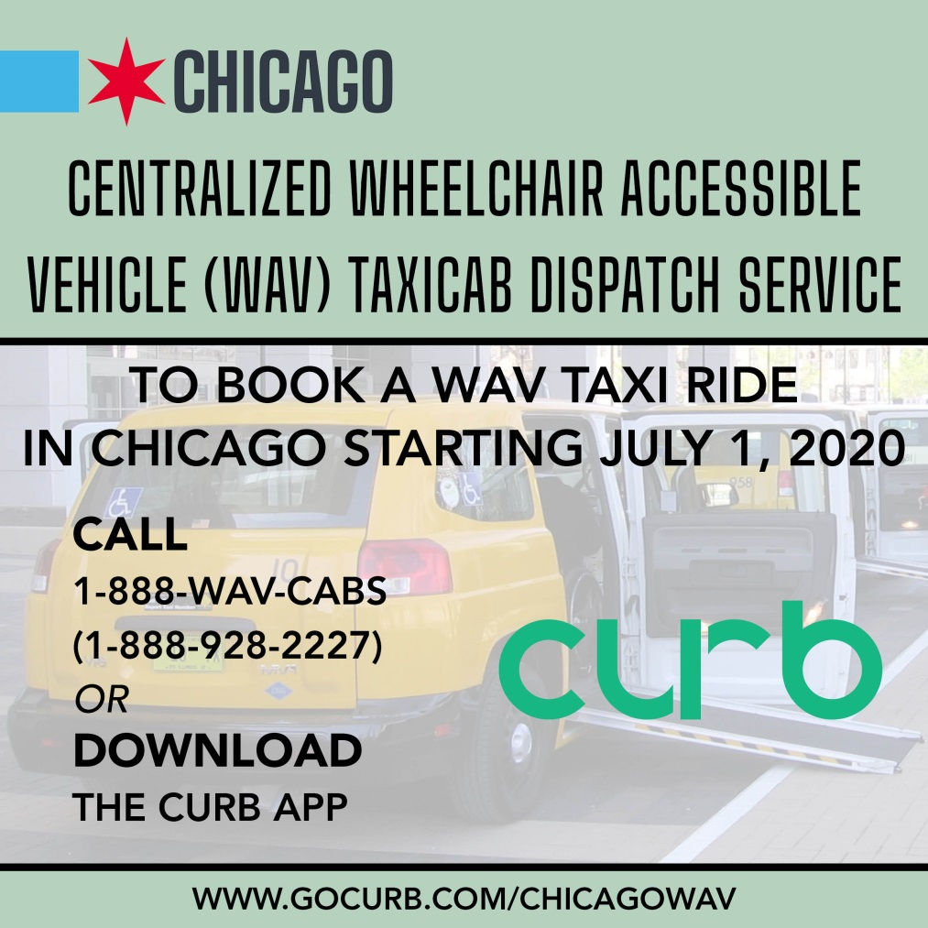

June 16, 2020 Notice – City of Chicago selects CURB to manage the City’s Centralized Wheelchair Accessible Vehicle (WAV) Taxicab Dispatch Service
Please be advised that the City of Chicago Department of Business Affairs and Consumer Protection (BACP) and Curb Mobility, LLC (CURB) have entered into a contract for CURB to manage the City’s Centralized Wheelchair Accessible Vehicle (WAV) Taxicab Dispatch Service.

Beginning July 1, 2020, passengers can request a WAV taxicab ride by calling 1-888-WAV-CABS (1-888-928-2227) or by downloading the CURB app. Passengers will also be able to make in-app electronic payments for their rides via the CURB app. For more information, including steps on how to download the CURB app, visit gocurb.com/ChicagoWAV.

PACE Taxi Access Program (TAP) certified paratransit passengers may download the CURB app to request dispatch service. However, they should follow the protocols of the TAP User’s Guide , which requires TAP passengers to swipe their card in the card reader in the back of the taxi to deduct a ride at the end of the trip.

Prior to July 1, 2020, all taxicab medallion licensees, managers, and chauffeurs of WAV taxicabs should contact CURB at ChicagoWAV@gocurb.com or directly sign-up at https://gocurb.com/curb-drivers-chicago/ to ensure they are connected to the new system.

CURB’s proposal was selected through a competitive bid process. The selection was made by a committee including representatives from BACP, the Mayor’s Office for People with Disabilities (MOPD) and the Chicago Commission on Human Relations (CCHR). The selection committee was advised by additional representatives from MOPD, the Department of Assets, Information and Services (AIS), WAV taxicab drivers and WAV passengers who use wheelchairs. CURB’s proposal was selected due to their ability to elevate the customer service experience for WAV taxicab passengers by allowing passengers to use electronic payment methods within the CURB e-hailing app. CURB’s proposal is based on streamlining the dispatch process through integration with equipment currently in Chicago taxicabs and through the CURB app. CURB’s selection was also based on their extensive experience in mobile apps, dispatch technology and call center services.

The City of Chicago WAV Taxicab Dispatch Service concept has been in place for nearly 20 years. In 2013, the City of Chicago established the first contracted WAV Taxicab Dispatch Service to provide rapid, on-demand taxicab services for passengers with disabilities. In 2019, 82,000 rides were provided through the centralized WAV taxicab dispatch service, and passengers were connected to rides within 18 minutes. Passengers who use wheelchairs may continue to call 1-855-928-1010 to request a WAV taxicab in Chicago until June 30, 2020.

